# 

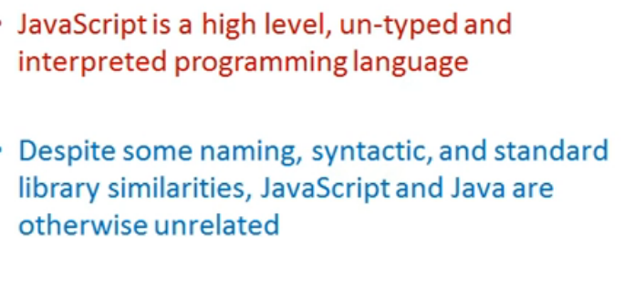

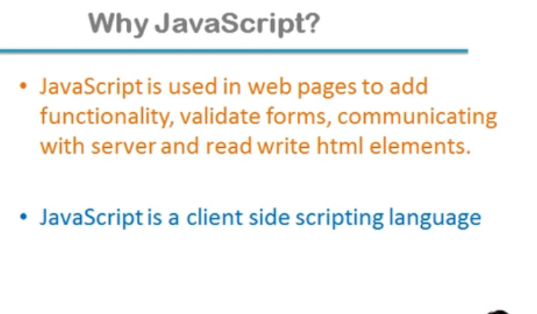

Css and hmtl both are not programming language. Programming language is one which take decision by its self

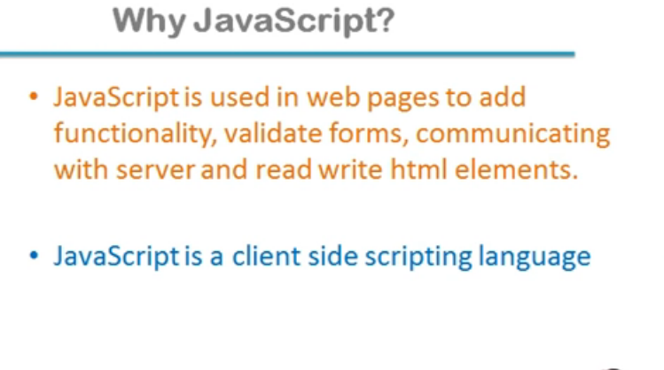

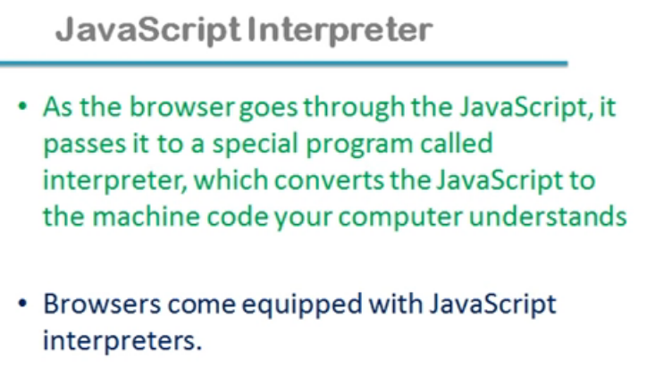

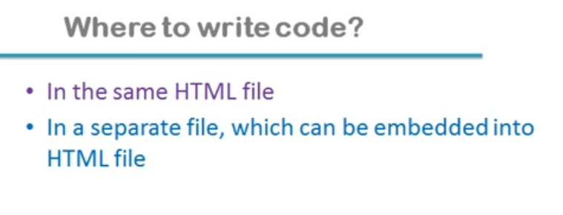

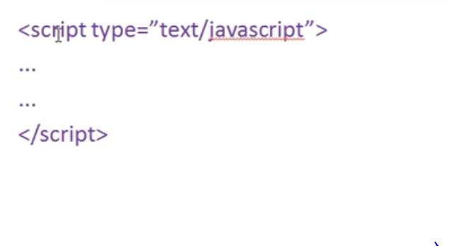

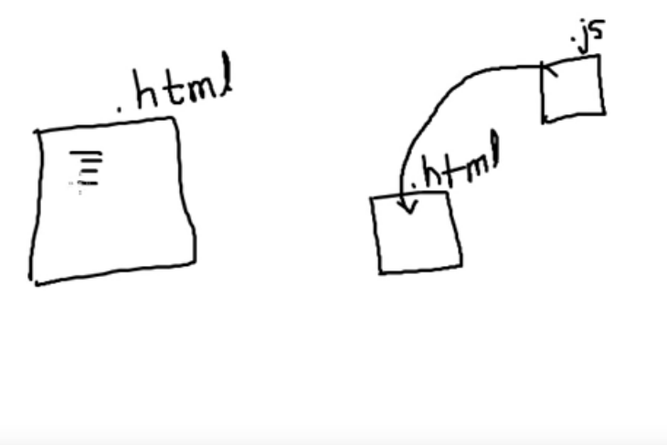

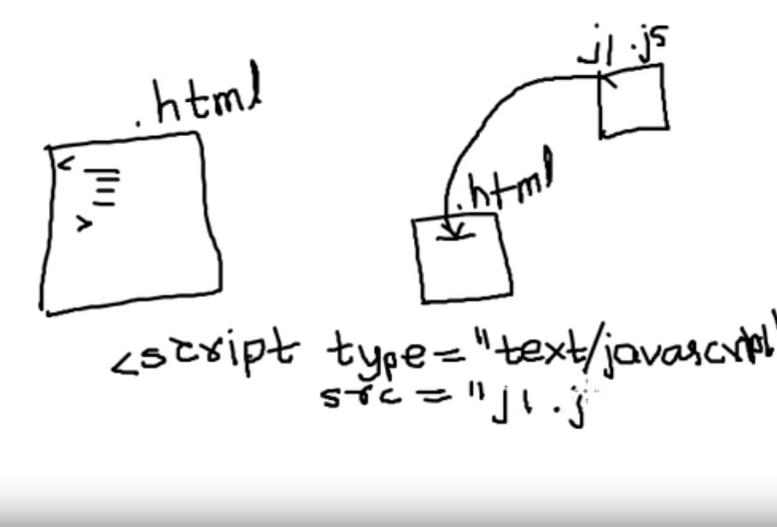

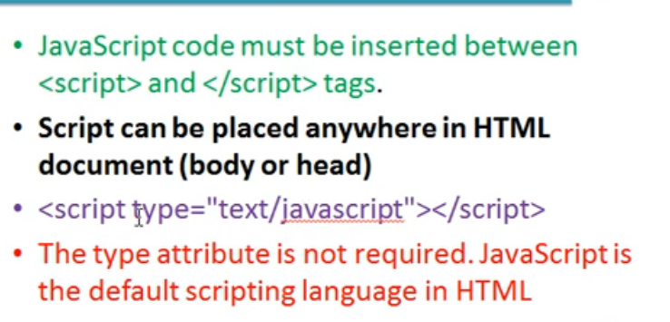

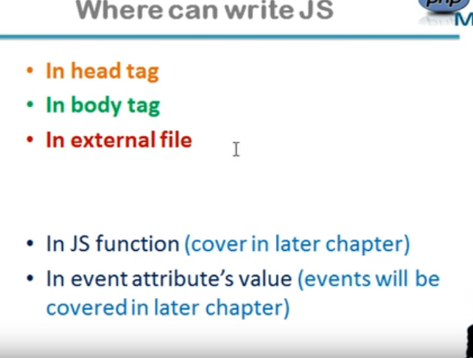

Document.write(“”);

This function works same as we do in c++ as cout

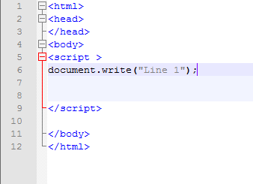

Output:



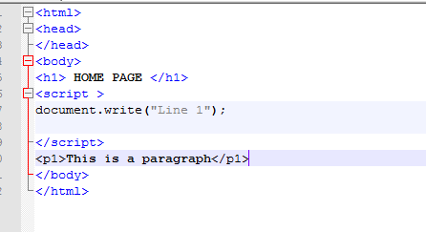

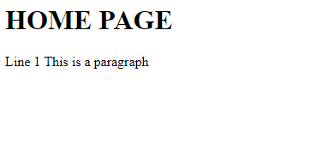

**In body this code run sequentically but if a palcew javascript in head so jaavascriptcode run first like**

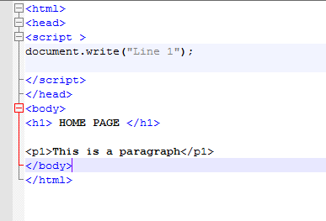

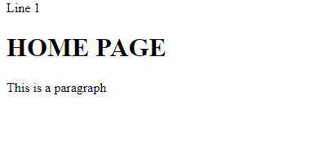

**This means that head tag commands run first in every execution**

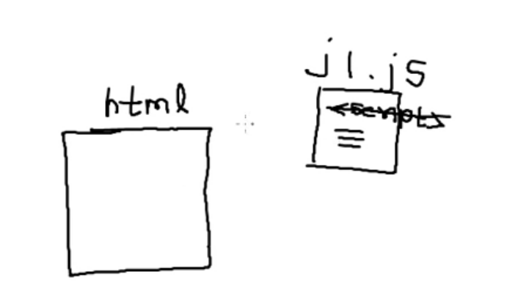

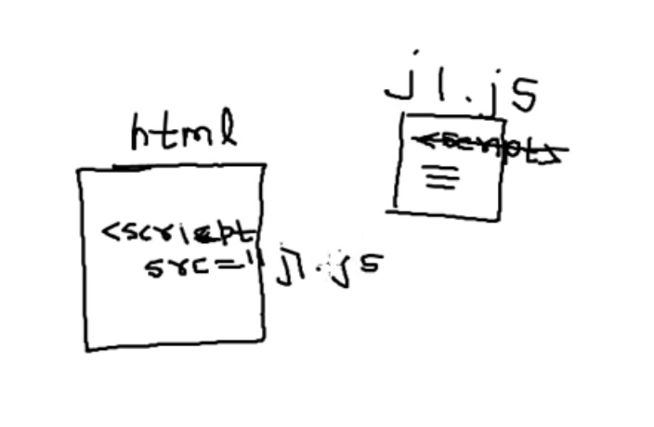

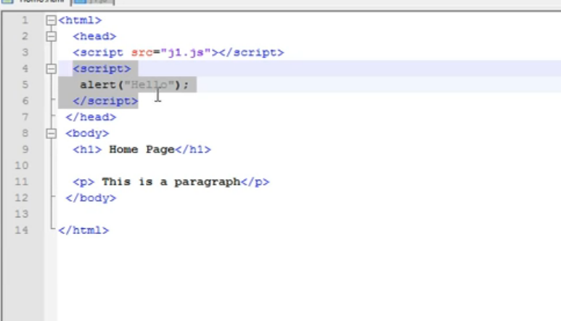

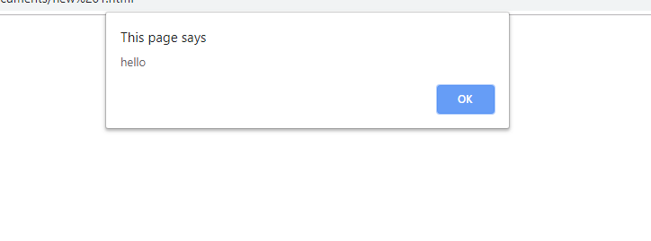

# Chapter 3 Basics of Javascript

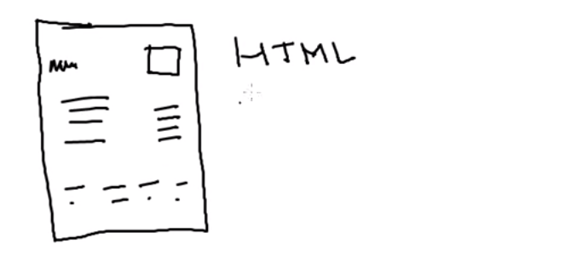

Ise ko html boltey h html decision nh le skta ..is m koi control statement nh mtlb if else or loops nh h but in javascript we have all these features

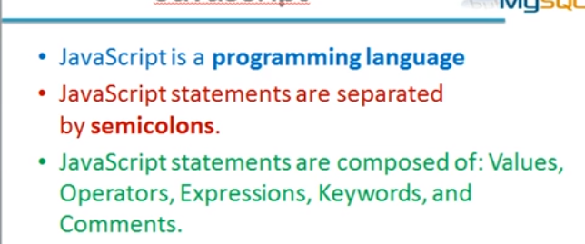

Java is influence to c.statement k end m semicolon lagna hota h

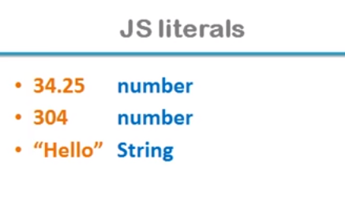

Constant literal hotey h …number or string dono hosktey h literal is different from variable

Varaible:DATA Sustain krta h jab tk uska scope hota h

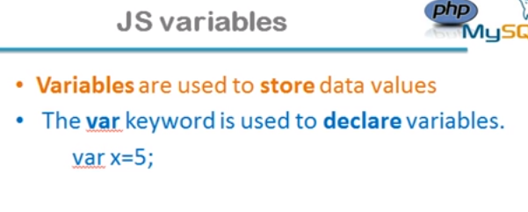

Variable garbage value ka concept nh hota agar intilize nh toh blank value print krega

: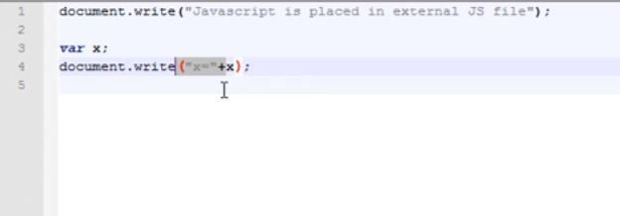

Output:

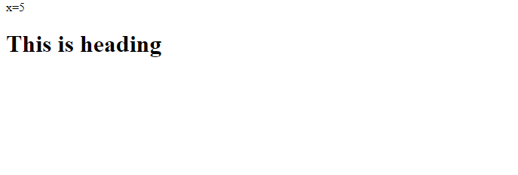

If we had intilize x so;

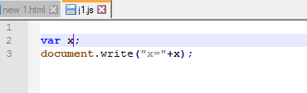

Output

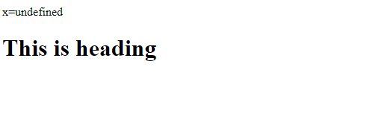

Unlike c and c++ hum khud variable ki type nh detey uski value decide krti h

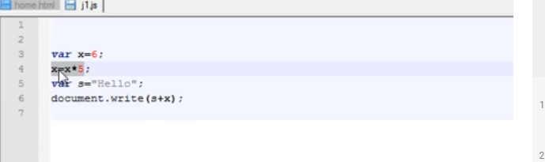

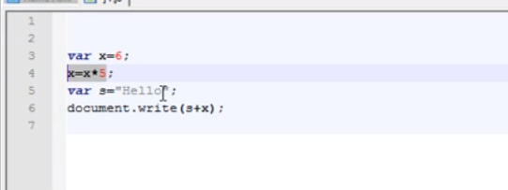

**Operator**

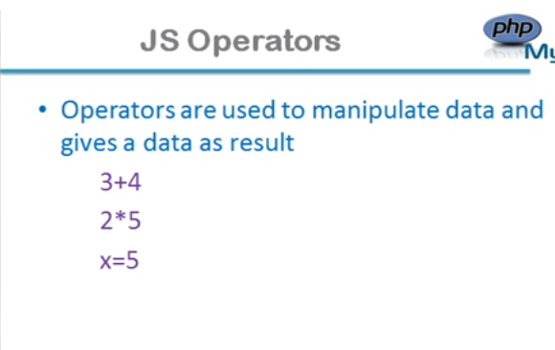

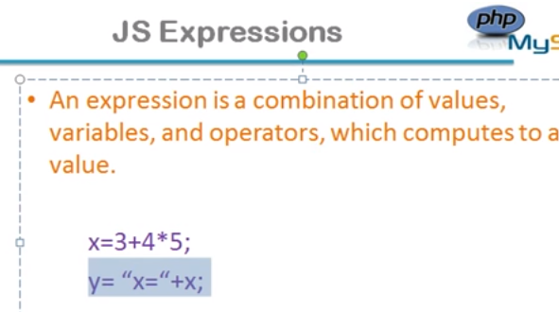

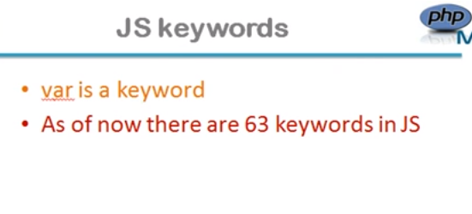

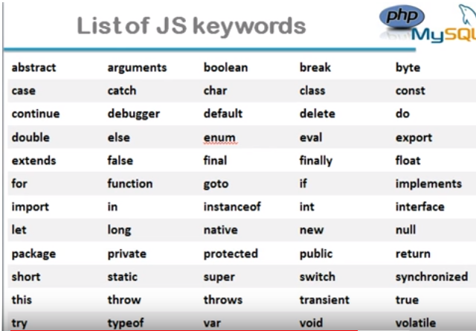

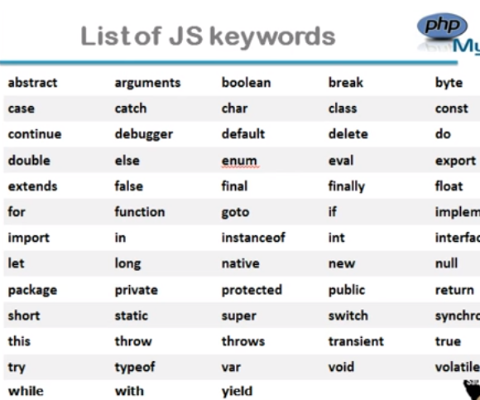

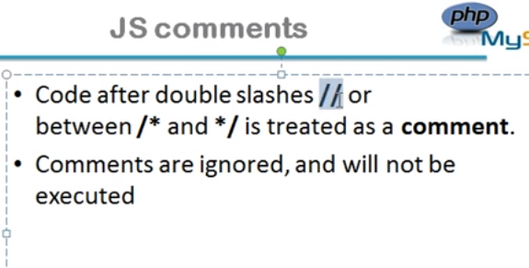

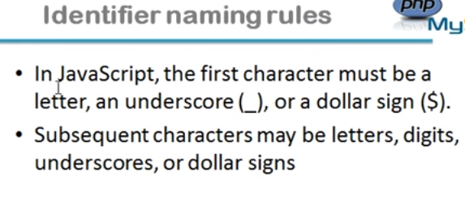

# Variables and operators in Javascript

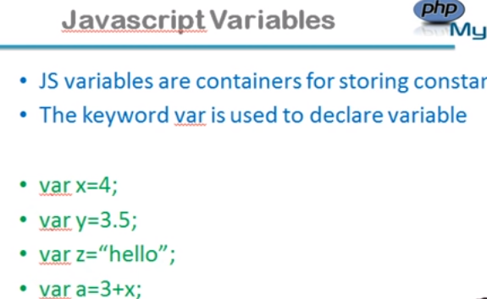

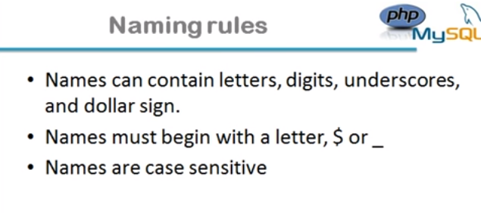

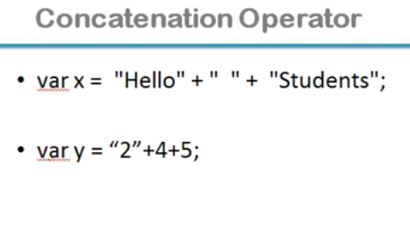

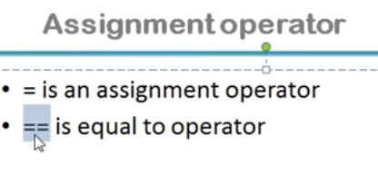**\**

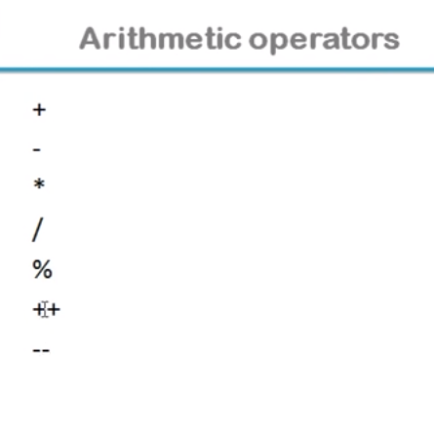

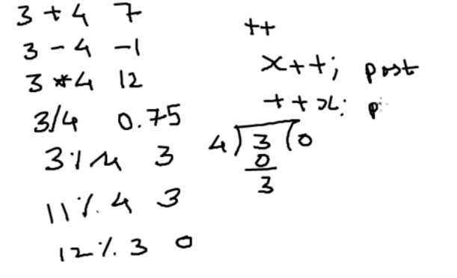

**Pre-increment priority is greater unlike post-increment.**

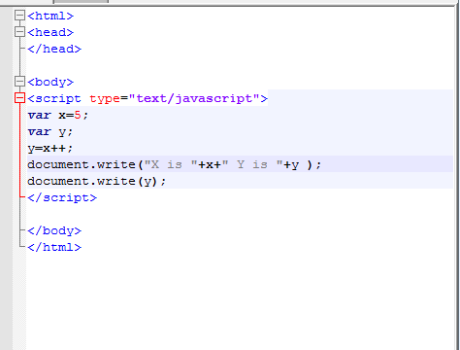



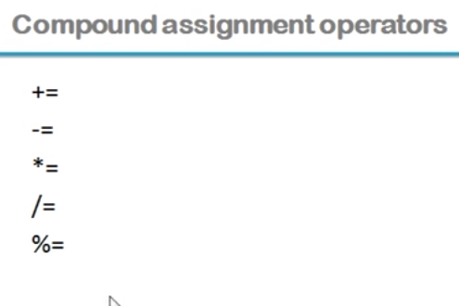

**Yahn se phle assignment hogi like x ki value y m chle jayegi then x increment hoga**

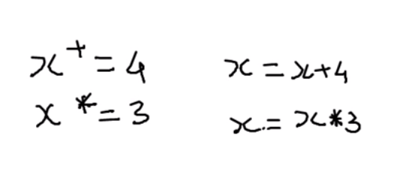

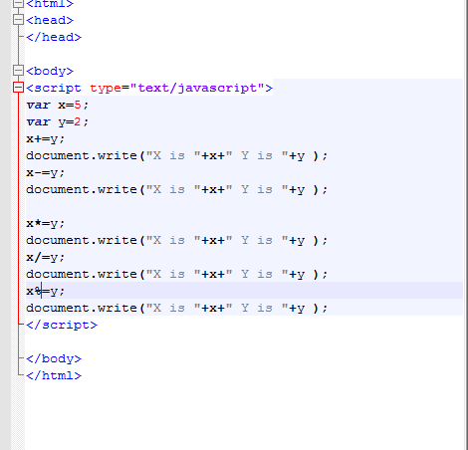

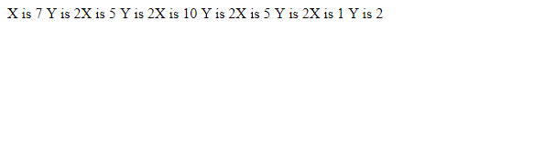

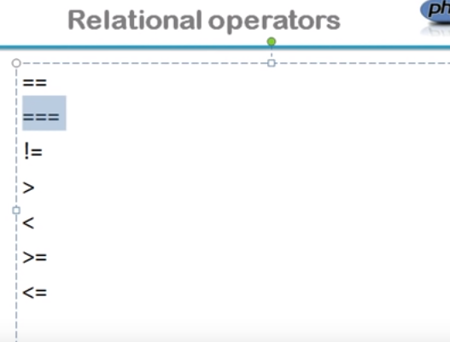

**=:for assignment**

**==:for equality**

**===:Check phase as well as type**

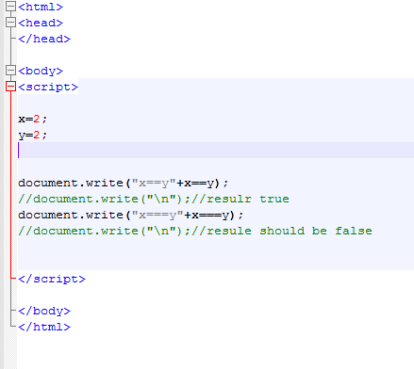

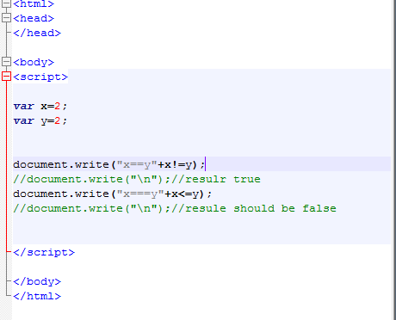

# Control Statements in Javascript

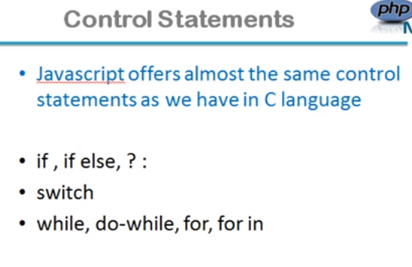

**Syntax:**

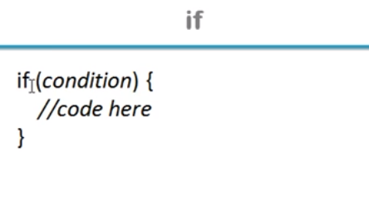

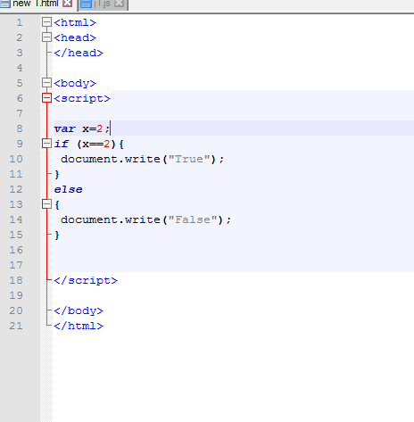

**Output:**

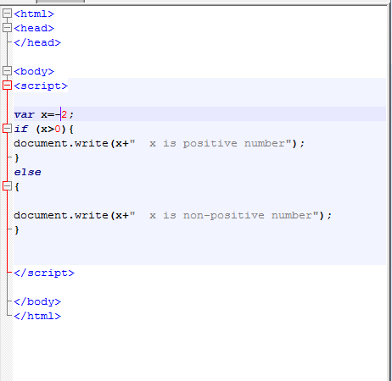

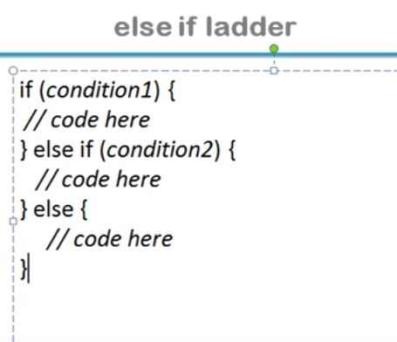

**Conditional Operator:**

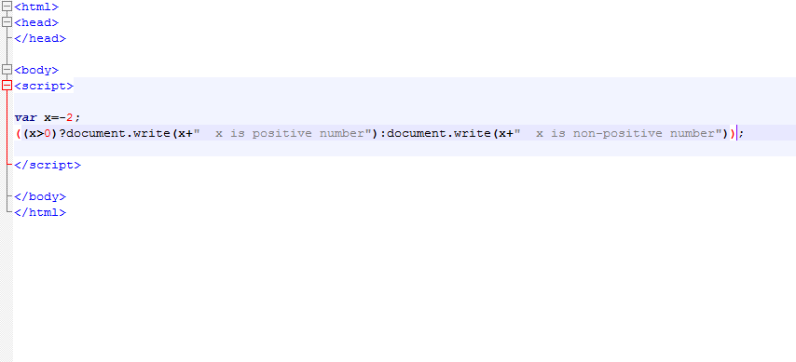

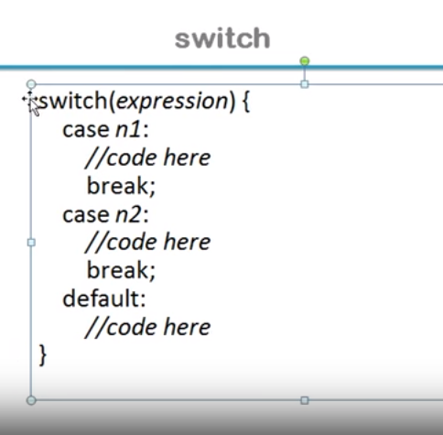

**Expression ka Iska result case ki**

**se match ki jayegi**

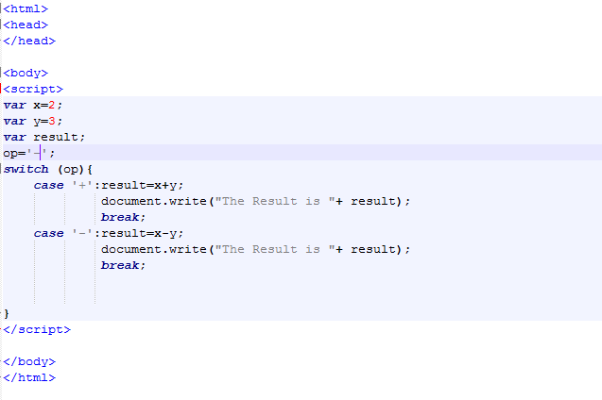

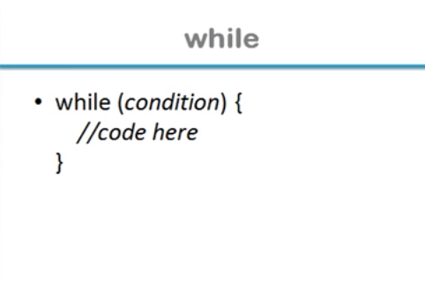

**While Example 1**

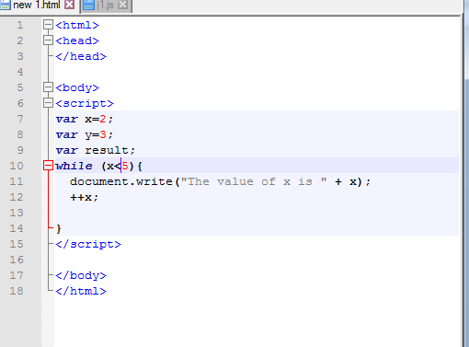

**While Example 2**

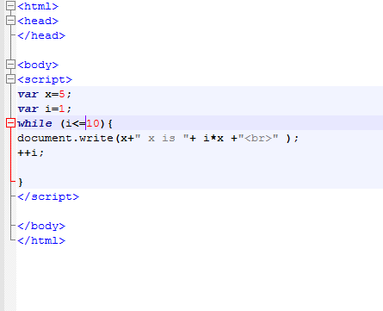

**Output:**

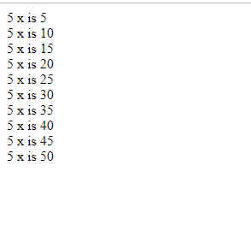

**Do While:**

**Example no 1:**

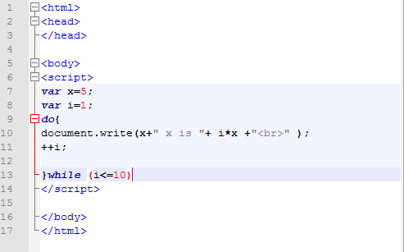

**For Loop**

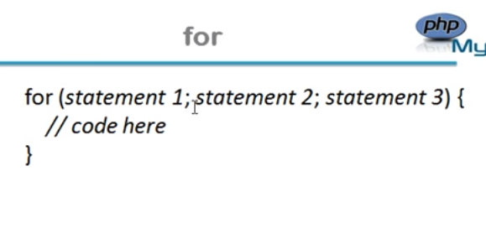

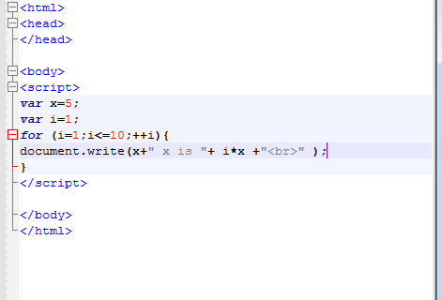

# Popup Boxes in Javascript

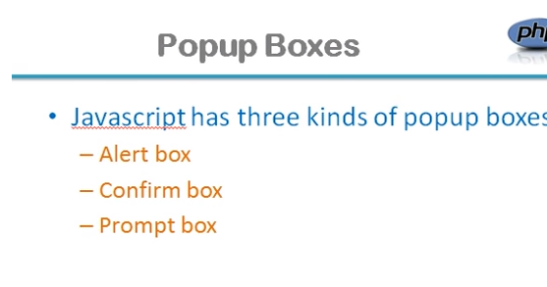

**It if from library name windows so we can also write as**

**Syntax:**

**Window.alert(“”);**

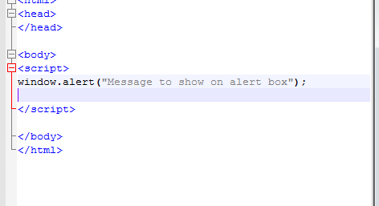

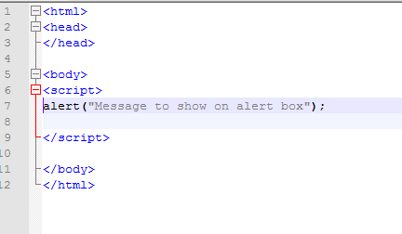

**Confirm box:**

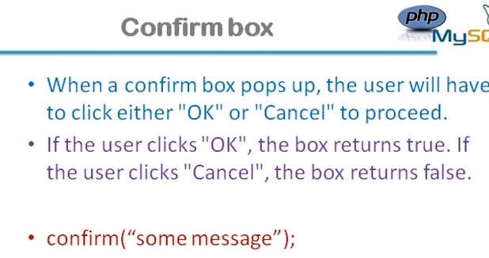

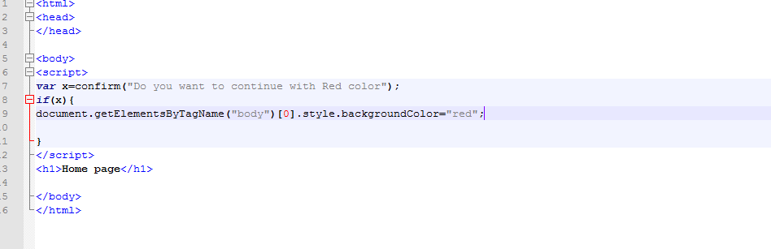

**“Prompt Box”:**

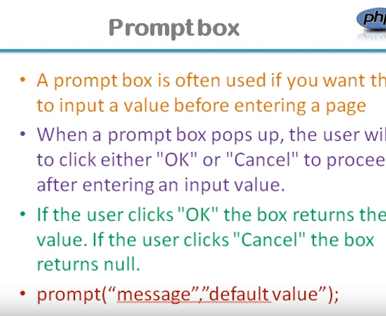

**Example no 1:**

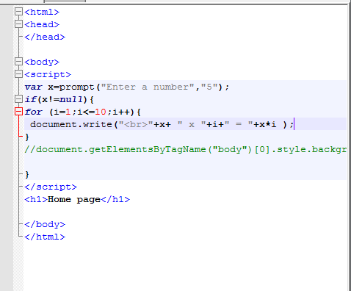

**Function**

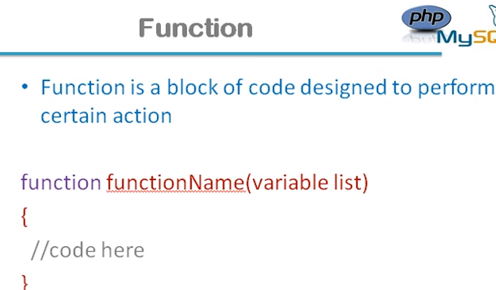

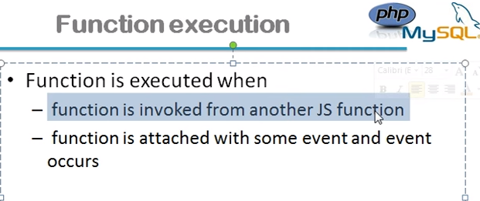

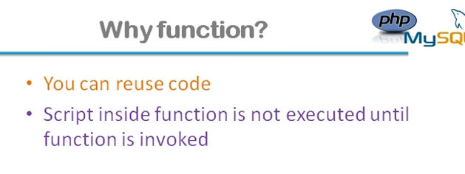

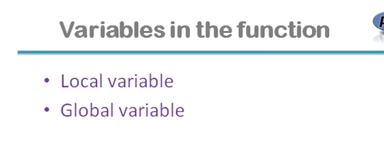

**Function k andar agar mne var lkh kr koi variable declare kia h toh it’s a local variable**

**And if not so it will be global variable**

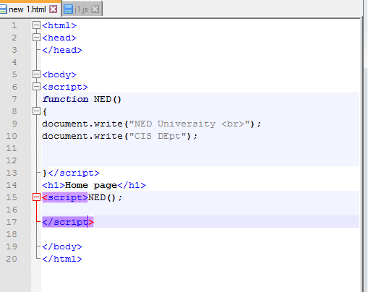

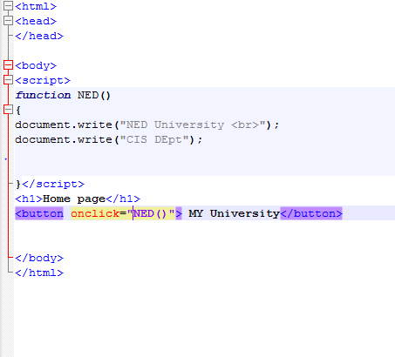

**Output**

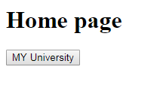

**On click our function page will open as we want we get desired result**

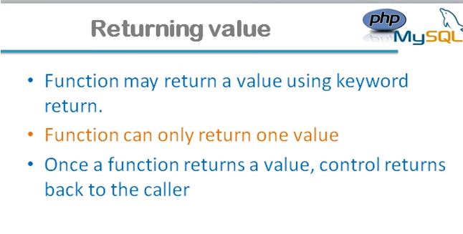

**Value jab return hoti h toh wahi jati h wahan se call hua h**

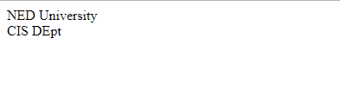

# Event Handling in Javascript

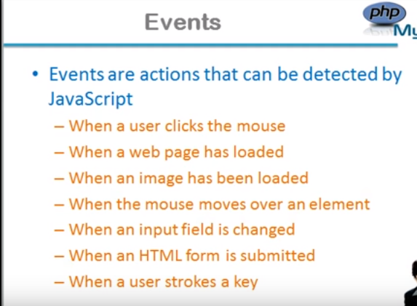

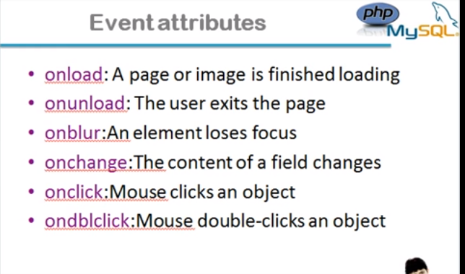

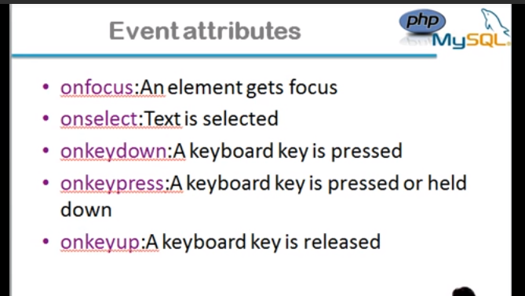

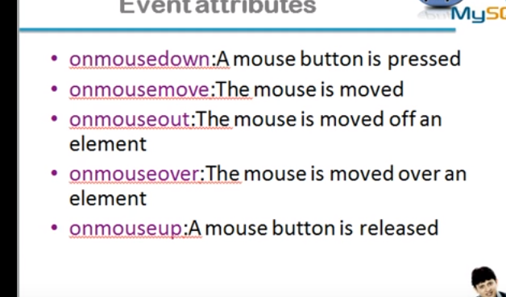

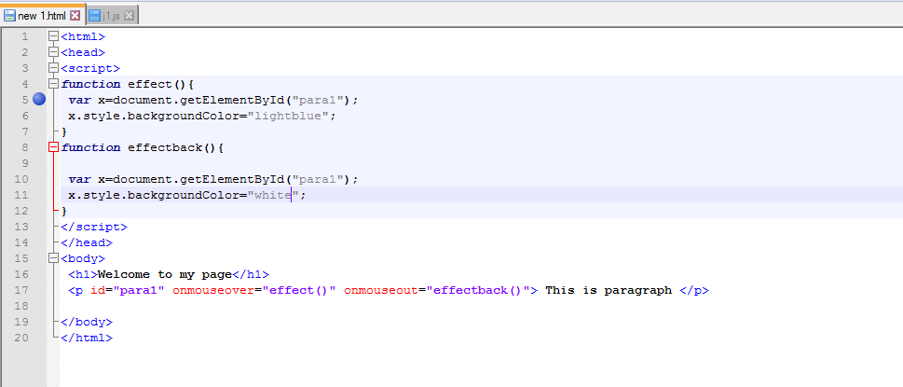

**Onmouseover pe blue color hojayega or dobara krne pe white hojayega**

# How to access HTML elements in Javascript

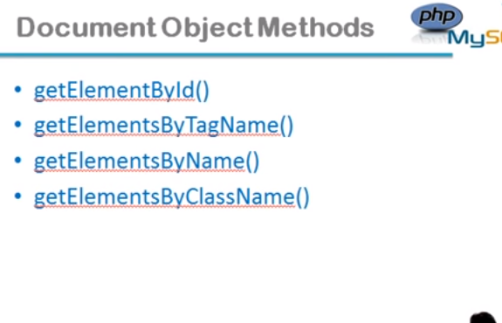

**Yeh function document object k method h yeh hume object bana kr derhe hh smjho is sab m eke k parguement pass hota h or wo string hota h**

**Id k ealwa sa object ka array return kregy isee leye element lkha h elements nh**

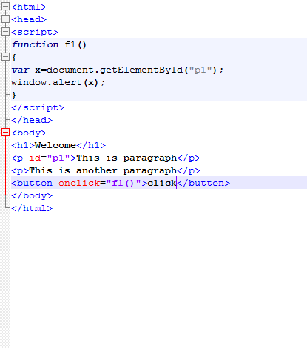

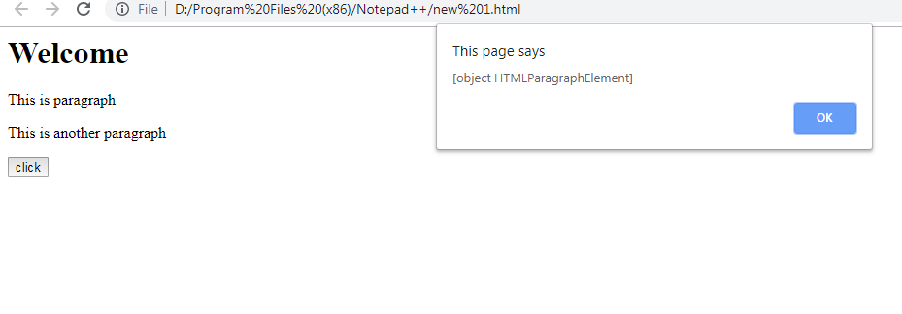

**innerHTML property us k contain ko repsrent kregaa**

**or agar getName to p ko kregaa**

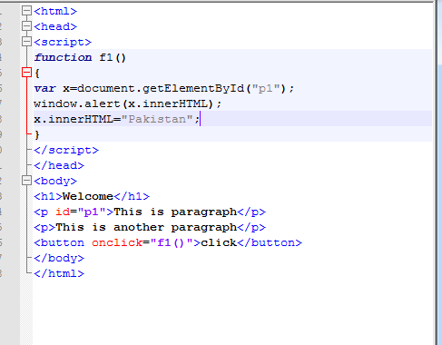

**Before clicking ok**

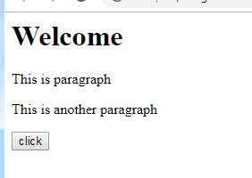

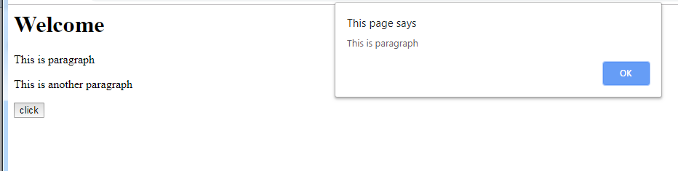

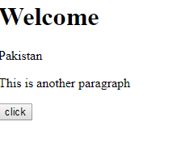

**DIY:**

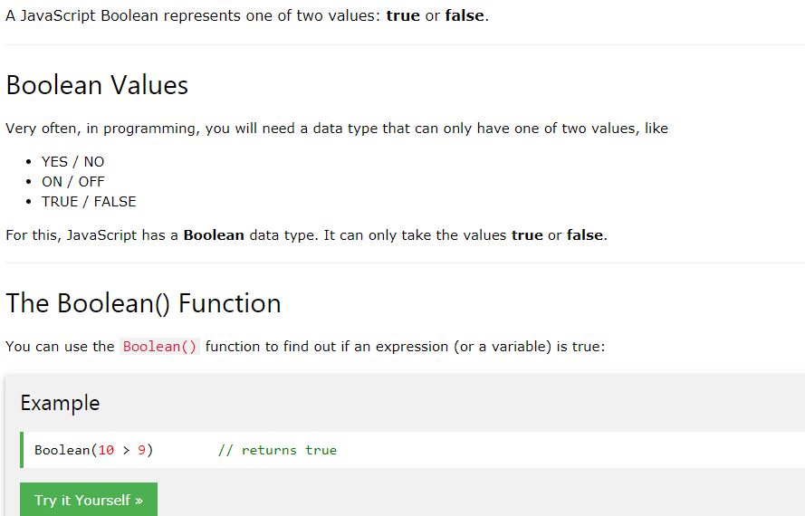

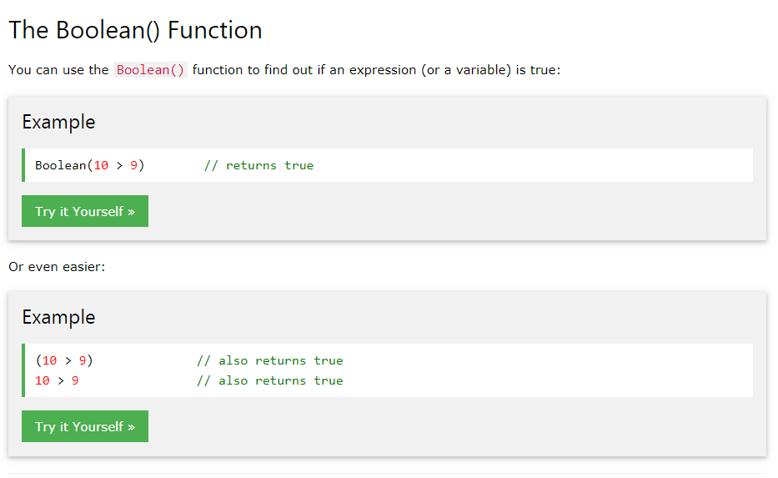

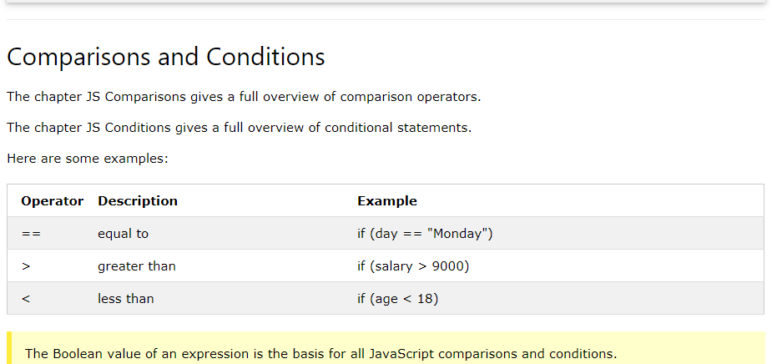

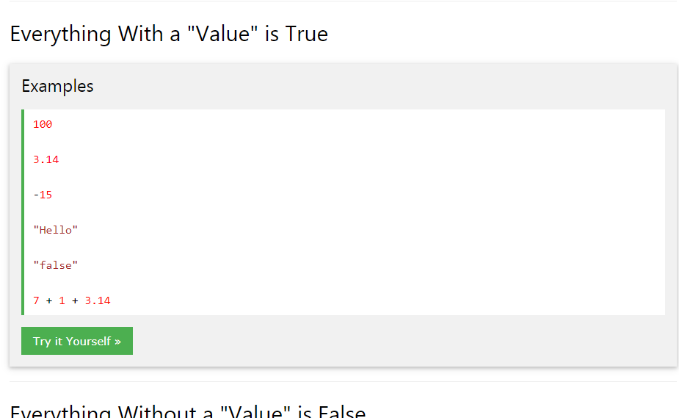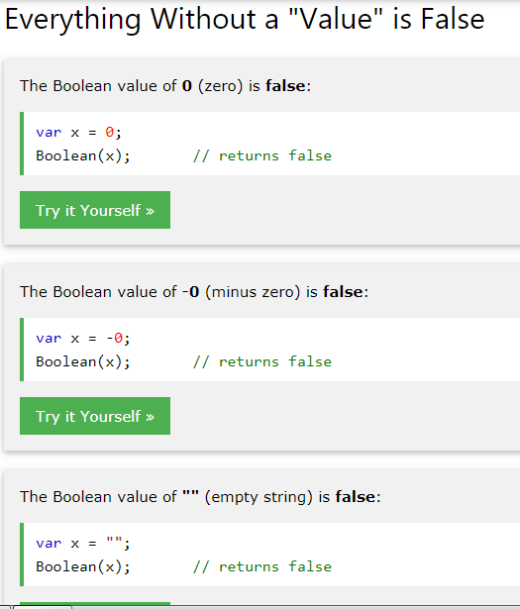

**Switch**

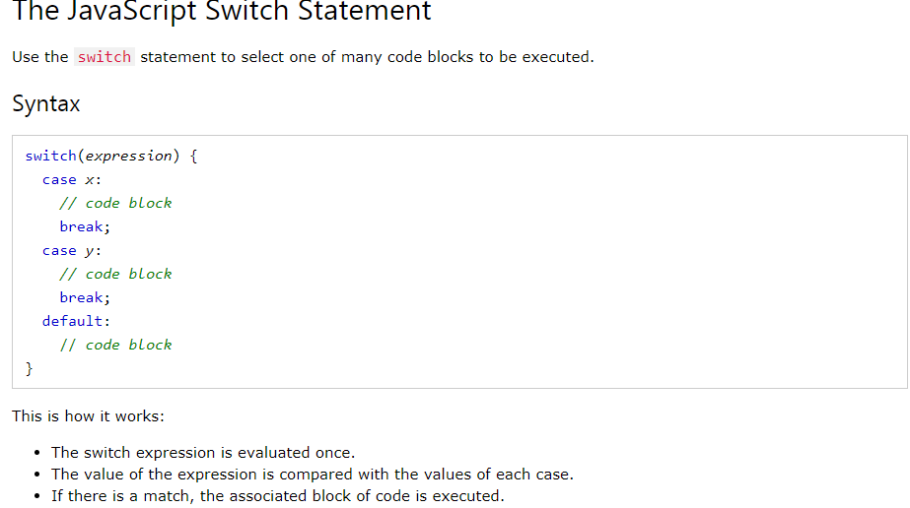

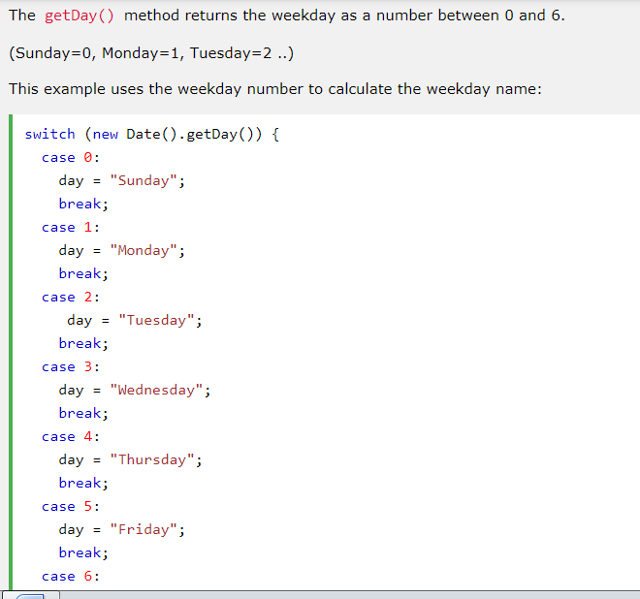

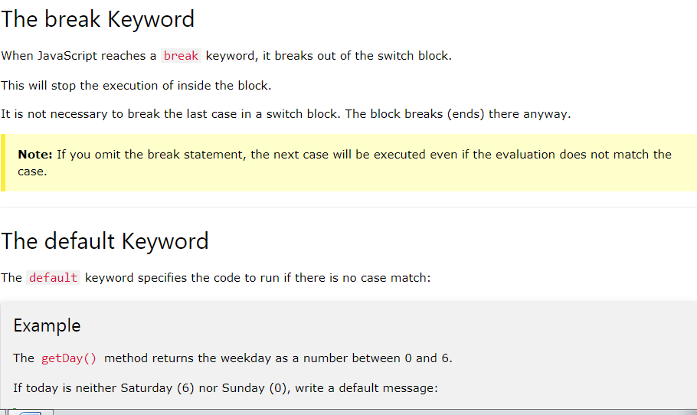

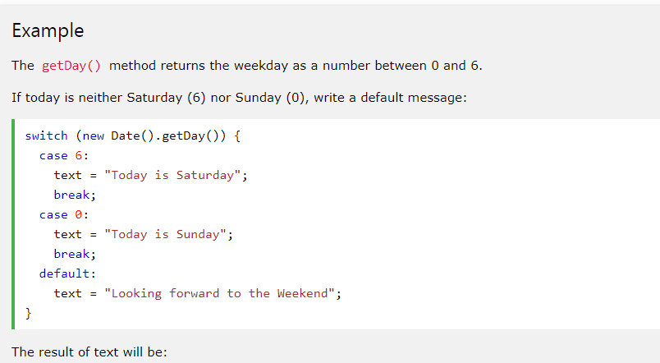

**Social Media:**

**//var list=["item1","item2","item3","item4"];**

**//console.log(list[0]);**

**­­**

**//var num=[1,2,3,4,5,6,7,8,9,0];**

**//var object={key:'Value1',key2:2,key3:false}**

**//.shift() is simply use for fire niklne k lye list se element**

**//var field=["batting","bowling","feilding","wicket_leeping"];**

**//var player = {**

**// name:"Tendulkar",**

**// age:28,**

**//height:5.7,**

**//married:true**

**//}**

**var database=[{**

**username:"Mohsin1",**

**password:"pass1"**

**},**

**{**

**username:"Mohsin2",**

**password:"pass2"**

**},**

**{**

**username:"Mohsi3",**

**password:"pass3"**

**}];**

**var newsfeed=[{**

**username:'John',**

**timeline:'Yeah ! i am so excited'**

**},**

**{**

**username:'Tommy',**

**timeline:'Yeah ! i am so tired'**

**}];**

**var usernamePrompt=prompt("Enter Your username");**

**var passwordPrompt=prompt("Enter Your Passowrd");**

**function validUser(user,pass){**

**for(i=0;i<database.length;i++){**

**if(user==database[i].username && pass==database[i].password){**

**return true;}//if**

**else**

**{ return false;**

**}//else**

**}//loop**

**}**

**function signIn(user,pass){**

**if (validUser(user,pass)){**

**console.log(newsfeed);**

**}**

**else**

**{**

**alert("Incorect Id or Passowrd");**

**}**

**}//func**

**signIn(usernamePrompt,passwordPrompt)**

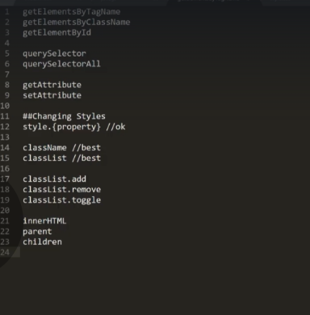

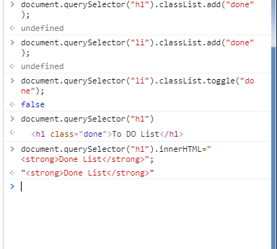

DOM Common Selectors

Following are the common DOM Selectors

getElementsByTagName

getElementsByClassName

getElementById

querySelector

querySelectorAll

getAttribute

setAttribute

##Changing Styles

style.{property} //ok

className //best

classList //best

classList.add

classList.remove

classList.toggle

Bonus Command

innerHTML

parentElement

children

##It is important to CACHE selectors in variables

**Page DO TO LIST**

**Javascript file:**

**var button= document.getElementById("enter");**

**var input= document.getElementById("userinput");**

**var ul=document.querySelector("ul");**

**function inputLength(){**

**return input.value.length;**

**}**

**function ListElement(){**

**var li = document.createElement("li");**

**li.appendChild(document.createTextNode(input.value));**

**ul.appendChild(li);**

**input.value=" ";**

**}**

**button.addEventListener("click",function(){**

**if(inputLength() > 0){**

**console.log(input.value);**

**}//if**

**}//finction**

**)**

**input.addEventListener("keypress",function(event){**

**if(inputLength() >0 && event.keyCode==13){**

**console.log(input.value);**

**ListElement()**

**}//if**

**})**

**button.addEventListener("click",function(){**

**console.log("User Clicked");**

**})**

**HTML FILE:**

**<!DOCTYPE html>**

**<html>**

**<head>**

**<title>javaFile with DOM</title>**

**<link rel="stylesheet" type="text/css" href="style.css">**

**</head>**

**<body>**

**<h1>To DO List</h1>**

**<p id="first">Jobs to Do Today</p>**

**<input id="userinput" type="text" placeholder="Enter Items Here">**

**<p class="second">This is Class Text</p>**

**<button id="enter">Click</button>**

**<ul>**

**<li random="23">Wake Up</li>**

**<li>brush teech</li>**

**<li>go to work</li>**

**<li>play footbal</li>**

**</ul>**

**<script type="text/javascript" src="java.js"> </script>**

**</body>**

**</html>**

***CSS FILE***

***.done{***

**text-decoration: line-through;**

**}**

**function isUserValid(bool){**

**return bool;**

**}**

**var login=isUserValid(false)?"Login Succes" | "Login Denied";**

**function motion(direction){**

**var move;**

**switch(direction){**

**case "up":var move="You are flying";**

**break;**

**case "down":var move="You are going down";**

**break;**

**case "right":var move="You are moving right ";**

**break;**

**case "left":var move="You are moving left";**

**break;**

**}//switch**

**}**

**Code With harry**

**<script type="text/javascript">**

**console.log({harry:"this"})**

**console.table({harry:"Table"})**

**console.warn("This is warning")**

**console.timeEnd('Your code end')**

**var age=120**

**console.assert(age>189,"Not possible")**

**console.error("This is an error")**

**/*Mutiline error*/**

**// var,let,const is type k varibel bantey h**

**var age=10**

**var age1**

**if(age==10){**

**console.log("Hello");**

**}**

**</script>**

**var name="Harry"**

**var channel;**

**var marks=3444**

**console.log(name,channel,marks)**

**Const and let:**

**<script type="text/javascript">**

**const ownersName="Hari Ram";**

**console.log(ownersName) //const aise varible jo chnage nh hosktey**

**/*let simply use istead of va ryeh apne scope m hi use hota h iska apna scope hota h har varible ka let=Block leevl scope */{**

**let city="RamPur"**

**console.log(ci­­ty);**

**}**

**const arr1=[1,2,3,4,5,6];**

**arr1.push(45)**

**console.log(arr1);**

**const object={**

**1:{11:"oneone"},**

**2:{22:"twotwo"}**

**}**

**console.log(object)**

**</script>**

**Primivitive database m memoryallocation stack m hota h (Base)**

**reference data m heap m store hota h(Object classes)**

**Permitive datatype:**

**1-string**

**2-number**

**3-boolean**

**4-undefined**

**5-sysmbol**

**Reference DataType:**

**1-Array**

**2-Object literal**

**3-Functions**

**4-Dates**

**<script type="text/javascript">**

**/**/**

**let name="Harry"**

**console.log("My string is "+typeof(name))**

**myarr=[1,2,4,5,,7,"string",true]**

**console.log("Data type is "+typeof(myarr))**

**//**

**let marks={**

**'harry':89,**

**'shutam':34,**

**'rohamDas':33**

**}**

**function findname(){**

**}**

**console.log(marks)**

**</script>**

**<script type="text/javascript">**

**/**/**

**let a=window;**

**console.log(a)**

**//allert is window object but window golabl h islye use mention nh krna parta**

**alert("Hello Man")**

**a=prompt("Ths is ")**

**a=confirm("Are You sure")**

**//these three alert prompt and comfirm are object of window yeh sare chzein ab website m use nh hota h**

**a=window.innerHeight;**

**console.log(a)**

**console.log(scrollY)**

**console.log(scrollX)**

**console.log(location) //give locations mean ip address wagera yeh sare chzein ab itne use nh hoti par maloom hona chahye**

***DOM:***

a=document.all;

console.log(a);

Array.from(a).forEach(function(element){

console.log(element)

//array form karo a ka or phir function alagaya us ko dia lement ko or element ko print krdia

})

b=document.links[0] //phela link dega

console.log(b)

**</script>**

**<!DOCTYPE html>**

**<html>**

**<head>**

**<title>Practice</title>**

**</head>**

**<body>**

**<p>**

**<div class="container">**

**<h1 id="heading">Welcome to club</h1>**

**<div class="child red" id="first">Child 1</div>**

**<div class="child">Child 2</div>**

**<div class="child red">Child 3</div>**

**<div class="child">Child 4</div>**

**<a href="www.facebook.com">Here</a>**

**</div>**

**<form action="none.html" method="post">**

**<input type="text" name="Hello" placeholder="hello">**

**<img src="2.jpg">**

**</form>**

**<div class="container" >**

**<span id="myText"></span>**

**</div>**

**<script type="text/javascript">**

**//to display all chzin in html page write**

**a=document.images**

**Array.from(a).forEach(function(element){**

**console.log(element);**

**})**

**</script>**

**</p>**

**</body>**

**</html>-**

**<script type="text/javascript">**

**/\***

**1-Single Element Selector**

**2-MultiSelector**

**\*/**

**let element=document.getElementById('first')**

**//element=element.childNodes;**

**//console.log(element)**

**//element=element.parentNode;**

**// console.log(element)**

**element.style.color ='red';­­**

**console.log(element)**

**element.innerText="Harry is a good boy"**

**element.innerHTML='<br>Hello World </br>'**

**let sel=document.querySelector('#first') // id jis ki firs tho wo select hojayeselector can be id**

**console.log(sel)**

**let sel1=document.querySelector('.child') //child class ka phlea element jo bhi h**

**console.log(sel1)**

**let sel2=document.querySelector('div') //phela hi div milega isse**

**sel2.style.color='blue';**

**let elemnt=document.getElementsByClassName('child');**

**console.log(elemnt)**

**let elem=document.getElementsByTagName('div');**

**Array.from(elem).forEach(element => {**

**console.log(element)**

**element.style='bold'**

**})**

**console.log(elem)**

**</script>**

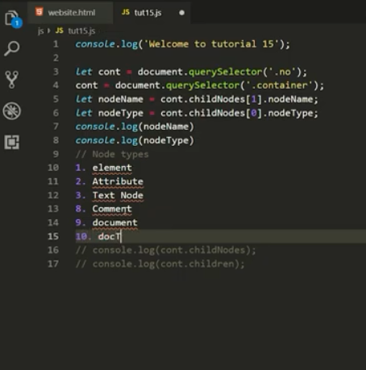

**let element=document.getElementById("first")**

**console.log(element)**

**console.log(element.parentNode)**

**element.parentNode.style.color='red'**

**console.log(element)**

**element.innerText="Harry harry"**

**element.innerHTML="Hello"**

**let element1=document.getElementsByTagName('div');**

**Array.from(element1).forEach(function(element){**

**console.log(element)**

**})**

**let contianer=document.querySelector('div .contianer')**

**console.log(contianer.lastChild)**

**console.log(contianer.lastElementChild)**

**console.log(contianer.childElementCount)**

**console.log(contianer.firstElementChild)**

**let element=document.createElement("li")**

**element.className='childul';**

**element.id="created"**

**//eleemnt create kr k usko class or id de h**

**element.setAttribute('title','myTitle')**

**element.innerHTML='Hello world'**

**let ul=document.querySelector('ul .this')**

**console.log(ul)**

**console.log(element)**

//console.log("Tuts 16")

//to create element in ava we use document .creat eelement

let element=document.createElement('li');

element.className='childul';

element.id='createdLI'

//console.log(element)

element.setAttribute('Title','Mytitle');

element.innerText="This is "

//ab kse fit kre dom m hume this class m dalna h toh phle this class ko slect kro phir us m append krdo

let ul=document.querySelector('ul.this');

//class bhi select hogaye ab append krna h

//console.log(ul)

ul.appendChild(element)

let element2=document.createElement('p')

element.innerHTML="This is created text"

element.className="created"

element.id="created"

let el=document.querySelector('div.container');

let text1=document.createTextNode("this is text node");

el.appendChild(text1)

//console.log(el)

el.appendChild(element2)

//hamesha 2 element create krne paregy ek jo bananna h dosre jis m select kr k add krna h

//How to replace an item

let elem2=document.createElement('h3')

elem2.id='elem2';

elem2.className="elem2";

let note=document.createTextNode("This is created note")

elem2.appendChild(note)

let ele=document.createElement('h1');

ele.className="marium"

ele.id='marium'

ele.innerText="This is Marium"

let ob=document.querySelector('div.container');

let myul=document.getElementById('myul')

console.log(ob)

ob.appendChild(note)

myul.replaceWith(ele,document.getElementById('fui'))

//to remove or add element zarori hona chahye k dosra ala arg phle wala ka child ho

myul.removeChild(document.getElementById('fui'))

/**Get attribue koi bhi attroibe lene k lye

 * has attt dkhne k lye k yeh att majood h na nh

 *

 *

 */

<!DOCTYPE html>

<html>

<head>

    <title>Javascript</title>

</head>

<body>

    <div class="container">

        <h1 id="heading"> Welcome to Code With Harry</h1>

        <div id="myfirst" class="child red good" id="first">child 1

            <ul class="this" id="myul">

                <li class="childul" id="fui">this</li>

                <li class="childul">is</li>

                <li class="childul">a</li>

                <li class="childul">list </li>

                <li class="childul"  id="lui">of my dreams</li>

            </ul>

        </div>

        <div class="child">child 2</div>

        <div class="child red">child 3</div>

        <div class="child">child 4</div>

        <form action="none.html" method="post">

            <a href="//codewithharry.com">Go to Code With Harry</a>

            <br>

            <br>

            Search this website: <input type="text" name="Hello" id="">

            <input type="button" value="submit">

        </form>

    </div>

    <br>

    <div class="no">this is a dummy div1</div>

    <div class="no">this is a dummy div2</div>

    <div class="no">this is a dummy div3</div>

        <!--

        <img src="2a.png">

    <img src="2b.png">

    <img src="2c.png">

    </div>  <a href="www.facebook.com">This Link1</a>

    <a href="www.facebook.com">This Link1</a>

    <a href="www.facebook.com"> Link1</a>

    <a href="www.facebook.com">This Link1</a>

    <a href="www.facebook.com">This Link1</a>-->

</body>

<script type="text/javascript"src="j2.js">

    </script>

</html>

/**------------------------------Events--------------------------- */

//browser k sth interact krne k lye event hotey h

/*

document.getElementById('heading').addEventListener('click',function(e){

    console.log('clicked');

    let varl=e.target

    varl=e.target.className;

    barl=e.target.classList;

    varl=e.clientX

    console.log(varl);

    //location.href="//www.facebook.com"; To redirect to someother page

})

document.getElementById('heading').addEventListener('mouseover',function(e){

    let varl1=e

    console.log(e)

})

let btn=document.getElementById('btn');

btn.addEventListener('click',func1);

function func1(e){

    //agar kse bhi defualt behavour ko khtm krna h toh we we ob.preventDefault

    a.preventDefault();

    console.log("Thanks ",e);

}

btn.addEventListener('mousedown',func2);

function func2(e){

    //agar kse bhi defualt behavour ko khtm krna h toh we we ob.preventDefault

    a.preventDefault();

    console.log("Thanks Mouse down ",e);

}

document.querySelector('.no').addEventListener('mouseenter',function(){

    console.log("Mouse enter")

})

*/

document.querySelector('.container').addEventListener('mousemove',function(e){

    console.log(e.offsetX)

    document.body.style.backgroundColor='red'

    console.log("Mouse move")

})

**Local Storage:**

**console.log('This is tut 20');**

**let impArray = ['adrak', 'pyaz', 'bhindi'];**

**// // Add a key-value pair inside local Storage**

**// localStorage.setItem('Name', 'Harry');**

**// localStorage.setItem('Name2', 'Rohan');**

**// localStorage.setItem('Sabzi', JSON.stringify(impArray));**

**// Clears the entire local storage**

**// localStorage.clear();**

**// Clear a particular key-value pair**

**// localStorage.removeItem('Name2');**

**// Retrieve an item from the local Storage**

**let name = localStorage.getItem('Name');**

**name = JSON.parse(localStorage.getItem('Sabzi'));**

**console.log(name)**

**// sessionStorage.setItem('sessionName', 'sHarry');**

**// sessionStorage.setItem('sessionName2', 'sRohan');**

**// sessionStorage.setItem('sessionSabzi', JSON.stringify(impArray));**

**Project (Note Taking )(Also in Github)**

**Index.hml**

<!doctype html>

<html lang="en">

  <head>

    <!-- Required meta tags -->

    <meta charset="utf-8">

    <meta name="viewport" content="width=device-width, initial-scale=1, shrink-to-fit=no">

    <!-- Bootstrap CSS -->

    <link rel="stylesheet" href="https://stackpath.bootstrapcdn.com/bootstrap/4.4.1/css/bootstrap.min.css" integrity="sha384-Vkoo8x4CGsO3+Hhxv8T/Q5PaXtkKtu6ug5TOeNV6gBiFeWPGFN9MuhOf23Q9Ifjh" crossorigin="anonymous">

    <title>Note Apps</title>

  </head>

  <body>

    <nav class="navbar navbar-expand-lg navbar-dark bg-dark">

        <a class="navbar-brand" href="#">Marium's Notes</a>

        <button class="navbar-toggler" type="button" data-toggle="collapse" data-target="#navbarSupportedContent" aria-controls="navbarSupportedContent" aria-expanded="false" aria-label="Toggle navigation">

          <span class="navbar-toggler-icon"></span>

        </button>

        <div class="collapse navbar-collapse" id="navbarSupportedContent">

          <ul class="navbar-nav mr-auto">

            <li class="nav-item active">

              <a class="nav-link" href="#">Home <span class="sr-only">(current)</span></a>

            </li>

          </ul>

          <form class="form-inline my-2 my-lg-0">

            <input id="searchTxt" class="form-control mr-sm-2" type="search" placeholder="Search" aria-label="Search">

            <button class="btn btn-outline-success my-2 my-sm-0" type="submit">Search</button>

          </form>

        </div>

      </nav>

      <div class="container my-5">

         <h1>Welcome to Mariums's Note</h1>

        <div class="card">

          <div class="card-body">

            <h5 class="card-title">ADD A NOTE</h5>

            <div class="form-group">

              <label for="exampleFormControlTextarea1">Example textarea</label>

              <textarea class="form-control" id="addTxt" rows="3"></textarea>

            </div>

            <button id="addBtn"class="btn btn-primary">Add note</button>

          </div>

        </div>

          <h1>Your Notes</h1>

          <hr>

          <div id="notes" class="container-fluid row">

          </div>

      </div>

    <!-- Optional JavaScript -->

    <!-- jQuery first, then Popper.js, then Bootstrap JS -->

    <script src="https://code.jquery.com/jquery-3.4.1.slim.min.js" integrity="sha384-J6qa4849blE2+poT4WnyKhv5vZF5SrPo0iEjwBvKU7imGFAV0wwj1yYfoRSJoZ+n" crossorigin="anonymous"></script>

    <script src="https://cdn.jsdelivr.net/npm/popper.js@1.16.0/dist/umd/popper.min.js" integrity="sha384-Q6E9RHvbIyZFJoft+2mJbHaEWldlvI9IOYy5n3zV9zzTtmI3UksdQRVvoxMfooAo" crossorigin="anonymous"></script>

    <script src="https://stackpath.bootstrapcdn.com/bootstrap/4.4.1/js/bootstrap.min.js" integrity="sha384-wfSDF2E50Y2D1uUdj0O3uMBJnjuUD4Ih7YwaYd1iqfktj0Uod8GCExl3Og8ifwB6" crossorigin="anonymous"></script>

    <script src="js/apps.js"></script>

</body>

</html>

**Js**

showNotes()

//if user add a note and add it to a localstorage

let addBtn=document.getElementById('addBtn').addEventListener("click",function(e){

    let addText=document.getElementById("addTxt")

    let notes=localStorage.getItem("notes");

    if(notes==null){

         notesobj=[];

    }

    else{

        //qk local storage se hume obj milta h or hum array m km krna charhe h islye json.parse

        notesobj=JSON.parse(notes)

    }

    notesobj.push(addText.value);

    localStorage.setItem("notes",JSON.stringify(notesobj))

    addText.value="";

    console.log(notesobj);

})

//read then show element from localstorage

function showNotes(){

    let notes=localStorage.getItem("notes");

    if(notes==null){

        notesobj=[]

    }

    else{

        notesobj=JSON.parse(notes)

    }

    //html var use ko display dynamil in index page

    let html="";

    notesobj.forEach(function(element,index) {

       html +=

      `<div class="mx-2 my-2 card noteCard" style="width: 18rem;">

      <div class="card-body">

        <h5 class="card-title">${index+1}</h5>

        <p class="card-text">${element}</p>

        <button id="${index}" onclick="deleteNotes(this.id)" class="btn btn-primary">Delete Note</button>

      </div>

    </div>`;

});

   let notesElm=document.getElementById('notes');

   if(notesobj.length!=0){

       notesElm.innerHTML=html;

  }

  else{

      notesElm.innerHTML=`Nothing to show!`;

    }

}

function deleteNotes(index){

    let notes=localStorage.getItem("notes");

    if(notes==null){

        notesobj=[]

    }

    else{

        notesobj=JSON.parse(notes);

    }

    //phlea index delete krdia splice se

    notesobj.splice(index,1)

    localStorage.setItem("notes",JSON.stringify(notesobj));

    showNotes()

  }

let search=document.getElementById('searchTxt');

search.addEventListener("input",function(){

    let inputval=search.value;

    console.log("Input event",inputval)

    let noteCards=document.getElementsByClassName('noteCard');

    Array.from(noteCards).forEach(element => {

        let cardTxt=element.getElementsByTagName('p')[0].innerText;

          if(cardTxt.includes(inputval)){

              element.style.display="block";

          }

          else{

            element.style.display="none";

          }

    });

})

**Maths and date**

console.log("Maths")

let x=3

let y=6

let z;

z=x+y

z=Math.PI

z=Math.ceil(5.6)

z=Math.round(4.5)

z=Math.floor(-5.3)

z=Math.abs(-5)

z=Math.sqrt(5);

z=Math.pow(2,3);

z=Math.min(2,3,4,5,666,777)

//50 or 100 k beach ka forumula banaya h

z=Math.ceil(50+(100-50)*Math.random(0,1))

console.log(z)

//Exploeing maths

let date=new Date()

console.log(date)

let otherDate=new Date('9-27-1997')

console.log(otherDate)

let a=otherDate.getDay()

a=otherDate.getFullYear();

a=date.getTime()

a=date.getMonth();

otherDate.setHours('23')

a=otherDate

otherDate.setFullYear('1998')

console.log(a)

**Object Oreinted Lammguage**

//object using object literals

let car={

    name:"Maruti 800",

    topSpeed:66,

    run:function(){

        console.log("Car is running");

    }

}

console.log(car)

//constructor

//new Date() -> This () is constructor

//creating cons

function GeneralCar(name,topSpeed){

    this.name=name;

    this.topSpeed=topSpeed;

    this.run=function(){

        console.log(`${this.name} is running`)

    }

    this.analyze=function(){

        console.log(`this car is slower by ${200-this.topSpeed} by mercedess`)

    }

}

car1 = new GeneralCar("Nissan",180)

//Object literal

let obj={

    name:"marium",

    channel:"Marium hhaha",

    "address":"Dnia"

}

function Obj(givenName){

   this.name=givenName

}

Obj.prototype.getName=function()

{

    return this.name

}

Obj.prototype.setName=function(newName){

    this.name=newName

}

let obj2=new Obj("Ebad")

console.log(obj2)

# ES6 Classes and Inheritance

class Employee{

    constructor(name,experince,division){

        this.name=name;

        this.experince=experince;

        this.division=division;

    }

    slogan(){

        return `I am ${this.name} and this is company`

    }

    joiningYear()

    {

        return 2020-this.experince

    }

    static add(a,b){

        return a+b

    }

   }

class Programmer extends Employee{

    constructor(name,experince,division,language,github){

        super(name,experince,division);

        this.language=language

        this.github=github

    }

   favoriteLanguage(){

        if(this.language=='Python'){

            return 'Python'

        }

        else{

            return 'Javascript'

        }

    }

    static mutilply(a,b){

        return a*b

    }}

harry=new Employee("marium",4,'A')

obj1=new Programmer("ebad","12","A","Pythhon","gg")

console.log(obj1.favoriteLanguage())

console.log(harry.slogan())

# What is Asynchronous Programming?

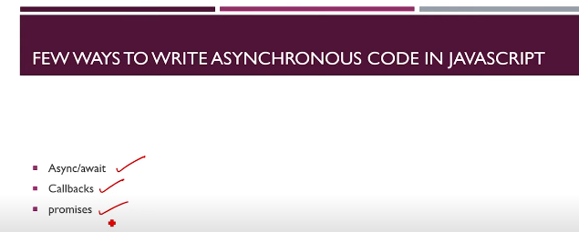

**Assy**

//Synchornous

setInterval(() => {

    for (let index = 0; index < 4000; index++) {

        const element = index;

        console.log("This is index number"+index)

    }

}, 100);

//set timeout se yeh assn hogaya ab wo for loop chlta rahega apne time se or dosra km bhi hota rahegaa

console.log("Done printing")

**CallBack:**

//Synchornous

/*setInterval(() => {

    for (let index = 0; index < 4000; index++) {

        const element = index;

        console.log("This is index number"+index)

    }

}, 100);

//set timeout se yeh assn hogaya ab wo for loop chlta rahega apne time se or dosra km bhi hota rahegaa

console.log("Done printing")*/

const students = [

    { name: "Harry", "subject": "javaScript" },

    { name: "Rohan Das", "subject": "Machine Learning" },

]

//function enrollStudent(students){

//yahan hum chahtey h k phle studetn add ho phir ead ho lkn huumne ise syn banaya hua h toh timing m ageey pechee ka isssue arha h

// islye we will make one callback function hume enrolledstudent m callback lagadia ta k

//jse hi wo khtm ho wo dosra function call karde ab yeh syntax h k ap dosre parameter m

//koi function dede ..humne callback isse rkha h k bd m jab code dkhe toh andaza hojaye

//function call krtey wqt ab callback  ki jaagh koi bhi func desktey h means

function enrollStudent(student,callback){

    setTimeout(function() {

        students.push(student)

        callback();

    },3000);

}

function getStudent(){

setTimeout(function() {

    let str="";

    students.forEach(student=> {

        str+=`<li>${student.name}</li>`

});

body=document.getElementById("student");

body.innerHTML=str

},1000);  }

let newStudent={'name':"Heehehe","subject":"Rona"}

  enrollStudent(newStudent, getStudent)

**Imdex of Callback**

 <h1>Student List</h1>

    <ul id="student"></ul>

# Promises Basics, Promise.then() & Promise.catch() :

//promises ka basically use wahan hota h jab hum network ya xhr object se kuch chz mangtry h wahan 2 condicion hoskti h ya toh wo km hojayegaa means resolve hojayegaa ya wo reject hojayegaa means nh hopayegaaa

//promises ka oj=bject create krna parta h

const students = [

    { name: "Harry", "subject": "javaScript" },

    { name: "Rohan Das", "subject": "Machine Learning" },

]

//function enrollStudent(students){

//yahan hum chahtey h k phle studetn add ho phir get ho lkn huumne ise syn banaya hua h toh timing m ageey pechee ka isssue arha h

// islye we will make one callback function hume enrolledstudent m callback lagadia ta k

//jse hi wo khtm ho wo dosra function call karde ab yeh syntax h k ap dosre parameter m

//koi function dede ..humne callback isse rkha h k bd m jab code dkhe toh andaza hojaye

//function call krtey wqt ab callback  ki jaagh koi bhi func desktey h means

//jo km callback se horha h wohi hum promisses se bhi krsktey h

function enrollStudent(student){

   return new Promise(function(resolve,reject){

    let error=false

    if(!error){

    setTimeout(function() {

students.push(student)

        resolve();

        console.log("Resoleved")

    },3000);

   }

   else{

       reject()

   }

})

}

function getStudent(){

setTimeout(function() {

    let str="";

    students.forEach(student=> {

        str+=`<li>${student.name}</li>`

});

body=document.getElementById("student");

body.innerHTML=str

},1000);  }

let newStudent={'name':"Heehehe","subject":"Rona"}

enrollStudent(newStudent).then(function(){

    getStudent();

}).catch(function(){

    console.log("Error")

})

function func1(){

    return new Promise(function(resolve,reject){

        setTimeout(() => {

            const error=false;

            if(!error){

                console.log("Your promise has been resolved");

                resolve();

            }

            else{

                console.log("Your promise has been reject");

                reject('Sorry not full fill')

            }

        }, 2000);

    }

    )}

    func1().then(function(){

        console.log("Thanks for resolving")

    }).catch(function(){

        console.log("Bad")

    })

# Arrow functions in Javascript

//we have three ways of defining function

function harry1(){

    console.log("Method 1 of defining Function")}

const harry2=function(){

    console.log("Method 2 of defining Function")}

const harry3=()=>{console.log("Method 3 of defining Function")}

harry1()

harry2()

harry3()

const greet= ()=> "Good Morning";

console.log(greet())

const greet1 = (name,ending)=> "Hello" + name + "Good Morning" +ending

console.log(greet1("Marium","Now okay bye"))

# Fetch api

console.log("Fetch API")

let myBtn=document.getElementById("myBtn")

let content=document.getElementById("content")

function getData(){

    url="harry.txt";

    fetch('harry.txt').then((response)=>{

        return response.text;

    }).then((data)=> {

        console.log(data)

    }

    )

}

getData()

**AJAX**

**JS:**

let fetchBtn = document.getElementById('fetchBtn');

fetchBtn.addEventListener('click', buttonClickHandler)

/*function buttonClickHandler(){

    console.log("Clickedc")

    //Instaite and xhr

    //ise yad nh krna ise documentation se dkh khe k krle

    const xhr=new XMLHttpRequest();

    //open the object

    //open txt

    xhr.open('GET','https://jsonplaceholder.typicode.com/todos/1',true);

    //The XMLHttpRequest.readyState property returns the state an XMLHttpRequest client is in.

    //progress wagera spinner laagne k lye km ayegaa

    xhr.onprogress=function(){

        console.log("On Progress");

    }

    xhr.onload=function(){

        if(this.status==200){

        console.log(this.responseText)}

        else{

            console.log("Sone Error Ocuur")

        }

    }

    //send bhi krna h

    xhr.send();

  //yeh we are done phle derha h qk humne apne code ko xhr ko block nh kia

    console.log("We are done")

}*/

function buttonClickHandler() {

    console.log("Clickedc")

    //Instaite and xhr

    //ise yad nh krna ise documentation se dkh khe k krle

    const xhr = new XMLHttpRequest();

    //open the object

    //open txt

    xhr.open('POST', 'http://dummy.restapiexample.com/api/v1/create', true);

    xhr.getResponseHeader('Content-type', 'application/x-www-form-urlencoded')

    //The XMLHttpRequest.readyState property returns the state an XMLHttpRequest client is in.

    //progress wagera spinner laagne k lye km ayegaa

    //post m data bhi bhjna h

    xhr.onprogress = function () {

        console.log("On Progress");

    }

    xhr.onload = function () {

        if (this.status == 200) { console.log(this.responseText) }

        else { console.log("Sone Error Ocuur") }

    }

    //send bhi krna h

    params = { "name": "test", "salary": "123", "age": "23" }

    xhr.send(params);

    //yeh we are done phle derha h qk humne apne code ko xhr ko block nh kia

    console.log("We are done")

}

//we can also do post werequest

let popBtn = document.getElementById("popBtn");

popBtn.addEventListener("click", popHandler)

function popHandler() {

    console.log("you clicked on populate")

    let xhr = new XMLHttpRequest();

    xhr.open('GET', 'http://dummy.restapiexample.com/api/v1/employees', true);

    xhr.onload = function () {

        if (this.status === 200) {

            let obj = JSON.parse(this.responseText);

            console.log(obj);

            let list = document.getElementById('list');

            str = "";

            for (key in obj) {

                str += `<li>${obj[key].employee_name} </li>`;

            }

            list.innerHTML = str;

        }

        else {

            console.log("Some error occured")

        }

    }

    xhr.send()

}

**Index:**

<h1>Ajax tutorial</h1>

    <button type="button" id="fetchBtn" class="btn btn-primary">Fetch Data</button>

    <button type="button" id="popBtn" class="btn btn-secondary">Populate</button>

    <div class="container">

        <h1>Employee list</h1>

        <ul id="list">

        </ul>

    </div>

**Fetch API:**

//fetch api is a new and modern standard we will kostily use fetch API

let myBtn=document.getElementById("myBtn");

let content=document.getElementById("content");

//fetch return a promise

//fetch m hamesha 2 then lagtey h

function getData(){

    console.log("Starting")

    url="https://api.github.com/users";

    fetch(url).then((response)=>{

        console.log("Inside 1st then")

        //repsonse.text se hume text return hoga wrna agar hum json lkhdety toh hume json m milega

        //return response.text()

        return response.json()

    }).then((data)=>{

        console.log("Insdie 2nd tthen")

        console.log(data);

    })

}

function postData(){

    url="   http://dummy.restapiexample.com/api/v1/create";

    data=   '{"name":"Marium12","salary":"123","age":"23"}';

    params={

        method:'post',

        headers:{

            'Content-Type':'application/json'},

        body:data}

    fetch(url,params).then(response=>response.json())

    .then(data=>console.log(data))

}

postData();

//yeh iska syntax h abhi k ly yad rklo post m hamesha aise hi hoga

# Async/Await in Javascript | JavaScript Tutorial In Hindi #43

//Asyn/Await m ahmesha 2 promises hotey h ek promise hota h jo khud promise return krta h

//asyn lagnese hamesha ek promise return hota h jis bhi func m asyn lkhahota h wo return krta h promise

function harry(){

    return "Harry"

}

console.log("Before function calling ")

let a=harry();

console.log(a)

**Error Handling:**

//Error handling agar koi error aye

let a=undefined;

if(a != undefined){

   throw new Error("This is not undefined")

}

else{

    console.log("This is  undefined")

}

try {

    console.log("We are inside try block")

    functionHarry()

} catch (error) {

    console.log("Are you Okay")

    console.log(error);

    console.log(error.name)

    console.log(error.message)

}finally{

   console.log("chahe error aye ya na aye we will run this")

}

# Using JavaScript Objects Exercise 5: Solution

let myJson=`{

    "word": "example",

    "results": [

      {

        "definition": "a representative form or pattern",

        "partOfSpeech": "noun",

        "synonyms": [

          "model"

        ],

        "typeOf": [

          "representation",

          "internal representation",

          "mental representation"

        ],

        "hasTypes": [

          "prefiguration",

          "archetype",

          "epitome",

          "guide",

          "holotype",

          "image",

          "loadstar",

          "lodestar",

          "microcosm",

          "original",

          "paradigm",

          "pilot",

          "prototype",

          "template",

          "templet",

          "type specimen"

        ],

        "derivation": [

          "exemplify"

        ],

        "examples": [

          "I profited from his example"

        ]

      },

      {

        "definition": "something to be imitated",

        "partOfSpeech": "noun",

        "synonyms": [

          "exemplar",

          "good example",

          "model"

        ],

        "typeOf": [

          "ideal"

        ],

        "hasTypes": [

          "pacemaker",

          "pattern",

          "beauty",

          "prodigy",

          "beaut",

          "pacesetter"

        ],

        "derivation": [

          "exemplify",

          "exemplary"

        ]

      },

      {

        "definition": "an occurrence of something",

        "partOfSpeech": "noun",

        "synonyms": [

          "case",

          "instance"

        ],

        "typeOf": [

          "happening",

          "natural event",

          "occurrence",

          "occurrent"

        ],

        "hasTypes": [

          "clip",

          "mortification",

          "piece",

          "time",

          "humiliation",

          "bit"

        ],

        "derivation": [

          "exemplify"

        ],

        "examples": [

          "but there is always the famous example of the Smiths"

        ]

      },

      {

        "definition": "an item of information that is typical of a class or group",

        "partOfSpeech": "noun",

        "synonyms": [

          "illustration",

          "instance",

          "representative"

        ],

        "typeOf": [

          "information"

        ],

        "hasTypes": [

          "excuse",

          "apology",

          "specimen",

          "case in point",

          "sample",

          "exception",

          "quintessence",

          "precedent"

        ],

        "derivation": [

          "exemplify",

          "exemplary"

        ],

        "examples": [

          "this patient provides a typical example of the syndrome",

          "there is an example on page 10"

        ]

      },

      {

        "definition": "punishment intended as a warning to others",

        "partOfSpeech": "noun",

        "synonyms": [

          "deterrent example",

          "lesson",

          "object lesson"

        ],

        "typeOf": [

          "monition",

          "admonition",

          "word of advice",

          "warning"

        ],

        "derivation": [

          "exemplary"

        ],

        "examples": [

          "they decided to make an example of him"

        ]

      },

      {

        "definition": "a task performed or problem solved in order to develop skill or understanding",

        "partOfSpeech": "noun",

        "synonyms": [

          "exercise"

        ],

        "typeOf": [

          "lesson"

        ],

        "examples": [

          "you must work the examples at the end of each chapter in the textbook"

        ]

      }

    ],

    "syllables": {

      "count": 3,

      "list": [

        "ex",

        "am",

        "ple"

      ]

    },

    "pronunciation": {

      "all": "ɪɡ'zæmpəl"

    },

    "frequency": 4.67

  }`

  document.getElementById("fetchBtn").addEventListener("click",definition)

function definition(){

    let list=document.getElementById("list");

    let str="";

  const myobj=JSON.parse(myJson);

  console.log("This object is ",myobj)

  console.log("This object result is  ",myobj['results'])

  let aray=myobj['results']

  aray.forEach(element => {

     str+=`<li>${element.definition}</li>`;

  });

  list.innerHTML=str

}

**Index.html**

<div class="container">

      <h1>Employee list</h1>

      <ul id="list">

      </ul>

  </div>

  <div class="content">

  </div>

# JavaScript Regular Expressions & related functions

console.log("exce agar hota h majood text toh yeh return krta h array,    test agar h toh return true else false then we have match method os tring class agar hota h toh it return array  then we have search function then replcawith")

console.log("Hello Reg");

let reg = /harry/g;//g means global

reg = /harry/i; //i flag means case-inseentive

console.log(reg)

//regular expression ko banaye k lye we need reg literals

//source hota h k reg eexp ki literal m kia lkha tha uska content

console.log(reg.source)

//Function to Match Expression;

//hum direclty wagera bhi search krsktry h basically reg searching m hi use hota h

let s = "This is a great code with Harry and also harry bhai ";

//1.exe() This return array for match and null for no-match

//yeh match ka index btata h

//mere pass 2 harry h but ek hi show horhaa h qk mne apne string ko globalThis; flag nh dia reg define krtey wqt agar m g dedo toh wo mjhe 2no locations dega

//2-test funcction means return true or false:agar wo reg expression h majood toh true milega wrna false milega

let result = reg.exec(s)

if (result) {

    console.log(result)

    result = reg.exec(s)

    console.log(result)

    result = reg.exec(s)

    console.log(result)

}

let result2 = reg.test(s);

console.log(result2)

//3.match() This apply on string it return array of result or null

//let result3=reg.match(a)--->This is wronghe

//yeh sare matches return kregaaa

let res=s.match(reg) ///This is rgiht phle string dene h phir function call krna h

console.log(res)

//4.search() -Return Index of first match else -1

//let result4=reg.match(a)--->This is wronge

let res1=s.search(reg) ///This is rgiht phle string dene h phir function call krna h

console.log(res1)

//5.replace-return news replace string with all the replacment;

//replace sirf phle wale ko replace krta h toh agar sabko krna h toh we use g in literals

let result5=s.replace(reg,'Marium')

console.log(result5)

//Excerise Solution

let reg=/marium/g;

let str="this is string which is created by marium and marium is working on that";

let result1=reg.exec(str);

console.log(result1)

result1=reg.exec(str);

console.log(result1)

let result2=reg.test(str);

console.log(result2)

let result3=str.match(reg);

console.log(result3)

let result5=str.search(reg);

console.log(result5)

let result4=str.replace(reg,"Harry")

console.log(result4)

# Regular Expressions - Metacharacters in JavaScript

//metacharacter symbol

let regx=/harry/;

regx =/^h/; //^ is work like a * agar koi h se shuru horhe h toh show krdo

regx=/ry$/; //akhir wale ko match krrhe h

regx=/h.rry/; //koi bhi ek character(dot) .

regx=/h*rry/; //matches any 0 or more characters

let str="harry is a good boy and harry is code with harry";

let result=regx.exec(str)

console.log("The result from exce is",result);

if(regx.test(str)){

    console.log(`The string ${str} ${regx.source} matches the expression `)

}

else{

    console.log("No match found")

}

# Regular Expressions - Character sets

//character sets

let regex = /h[a-z]rry/i;

regex = /h[0-9]rry/i; //can be -9

regex = /h[aty]rry/i; //can be aty

regex = /h[a-z]rry/i; //

//yeh [] character set k lye h k is jaagh a-z m kuch hotaa ya agar m yahan lkhdo

//[0-9 tih bhi match nh hoga

regex = /ha[^aty]ry/ // chahti k k a-x k beach m koi valu na ho agar mjhe aty ko match nh krwanaa

//square brcket laga kr us k beach m kuch dalna or agar wo  match hojata h toh ajayee this is called characters set

regex = /h[^aty]rr[yu]/

regex = /h[a-zA-Z]rr[yu]/

let str = "harry bhai";

str = "hirrt bhai" //This will not match

str = "hirry bhai" //This will match

str="hArry Bhai"

let result = regex.exec(str);

//Quantifiers :quantity measure krne k lye use hoti h /

regex=/har{0,2}/ //0 ya 2 character r k

str="harry bhai"

console.log("The Result from exc is", result);

if (regex.test(str)) { console.log(`The String ${str} mactches the expression ${regex.source}`);}

else { console.log("Not Found")}

# baki code with harry k website m dkhne h qk mjhe ye itna smjh nh arha tha

# Shorthand character classes:

# Project 4:Form-validation Regular Expression:

# Js file:

const name=document.getElementById("name");

const email=document.getElementById("email");

const phone=document.getElementById("phone");

let validEmail=false

let validPhone=false

let validUser=false

name.addEventListener('blur',()=>{

    console.log("name is blurred")

    let regex=/^[a-zA-Z]([0-9a-zA-Z]){2,10}$/

    let str=name.value;

    console.log(regex,str)

    if(regex .test(str)){

    name.classList.remove('is-invalid')

    validUser=true;

    }

    else{

        name.classList.add('is-invalid')

        validUser=false;

    }

})

email.addEventListener('blur',()=>{

    console.log("phone is blurred")

    let regex=/^([_\-\.0-9a-zA-z]+)@([0-9_\-\.a-zA-z0-9]+)\.([a-zA-Z]){2,7}$/

    let str=email.value;

    console.log(regex,str)

    if(regex .test(str)){

    email.classList.remove('is-invalid')

    validEmail=true;

    }

    else{

        email.classList.add('is-invalid')

        validEmail=false;

    }

})

phone.addEventListener('blur',()=>{

    console.log("email is blurred")

    let regex=/^([0-9]){11}$/

    let str=phone.value;

    console.log(regex,str)

    if(regex .test(str)){

        phone.classList.remove('is-invalid')

        validPhone=true;

    }

    else{

        phone.classList.add('is-invalid')

        validPhone=false;

    }

})

let submit=document.getElementById("submit")

submit.addEventListener("click",(e)=>{

    e.preventDefault();

    let failure=document.getElementById("failure")

    let success=document.getElementById("success")

    if(validEmail && validPhone && validUser){

        console.log("All Vaid")

        success.classList.add("show")

        $('#failure').alert('close');

    }

    else{

        console.log("one may be invalid")

       failure.classList.add("show")

       $('#success').alert('close');

    }

})

console.log(validEmail,validPhone,validUser)

# Index.html:

<!doctype html>

<html lang="en">

<head>

  <!-- Required meta tags -->

  <meta charset="utf-8">

  <meta name="viewport" content="width=device-width, initial-scale=1, shrink-to-fit=no">

  <!-- Bootstrap CSS -->

  <link rel="stylesheet" href="https://stackpath.bootstrapcdn.com/bootstrap/4.4.1/css/bootstrap.min.css"

    integrity="sha384-Vkoo8x4CGsO3+Hhxv8T/Q5PaXtkKtu6ug5TOeNV6gBiFeWPGFN9MuhOf23Q9Ifjh" crossorigin="anonymous">

  <title>Pakistan's Travel Desk!</title>

</head>

<body>

  <div id="success" class="alert alert-success alert-dismissible fade" role="alert">

    <strong>Success!</strong> Your travel request has been successfully submitted

    <button type="button" class="close" data-dismiss="alert" aria-label="Close">

      <span aria-hidden="true">&times;</span>

    </button>

  </div>

  <div id="failure" class="alert alert-danger alert-dismissible fade" role="alert">

    <strong>Error!</strong> Your travel request has not been send due to Error

    <button type="button" class="close" data-dismiss="alert" aria-label="Close">

      <span aria-hidden="true">&times;</span>

    </button>

  </div>

  <div class="container">

    <h1>Pakistan's Travel Desk</h1>

    <form>

      <div class="form-group">

        <label for="name">userame</label>

        <input type="text" class="form-control" id="name" placeholder="Enter your name">

        <small id="nameValid" class="form-text text-muted invalid-feedback">

          Your username must be 2-10 long.Must Start with aplhabet

        </small>

      </div>

      <div class="form-group">

        <label for="email">Email Address</label>

        <input type="text" class="form-control" id="email" placeholder="Enter your email">

        <small id="phoneValid" class="form-text text-muted invalid-feedback">

          Your email is invalid

        </small>

      </div>

      <div class="form-group">

        <label for="car">Select your car</label>

        <select class="form-control" id="car">

          <option>Omni</option>

          <option>Maruti 800</option>

          <option>Ford Titanium</option>

          <option>Audi A4</option>

        </select>

      </div>

      <div class="form-group">

        <label for="address">Enter your Address</label>

        <textarea class="form-control" id="address" rows="3"></textarea>

      </div>

      <div class="form-group">

        <label for="phone">Enter your phone number</label>

        <input type="phone" class="form-control" id="phone" placeholder="Enter your Phone Number">

        <small id="phoneValid" class="form-text text-muted invalid-feedback">

          Number must be in 11 digit long

        </small>

      </div>

      <div class="form-group">

        <label for="exampleFormControlTextarea1">Any other Message</label>

        <textarea class="form-control" id="msg" rows="3"></textarea>

      </div>

      <button id="submit" class="btn btn-primary">

        Submit

      </button>

    </form>

  </div>

  <!-- Optional JavaScript -->

  <!-- jQuery first, then Popper.js, then Bootstrap JS -->

  <script src="js/apps.js"></script>

  <script src="https://code.jquery.com/jquery-3.4.1.slim.min.js"

    integrity="sha384-J6qa4849blE2+poT4WnyKhv5vZF5SrPo0iEjwBvKU7imGFAV0wwj1yYfoRSJoZ+n"

    crossorigin="anonymous"></script>

  <script src="https://cdn.jsdelivr.net/npm/popper.js@1.16.0/dist/umd/popper.min.js"

    integrity="sha384-Q6E9RHvbIyZFJoft+2mJbHaEWldlvI9IOYy5n3zV9zzTtmI3UksdQRVvoxMfooAo"

    crossorigin="anonymous"></script>

  <scrip]\t src="https://stackpath.bootstrapcdn.com/bootstrap/4.4.1/js/bootstrap.min.js"

    integrity="sha384-wfSDF2E50Y2D1uUdj0O3uMBJnjuUD4Ih7YwaYd1iqfktj0Uod8GCExl3Og8ifwB6"

    crossorigin="anonymous"></script>

</body>

</html>

# Iterators in JavaScript

const myArray = ['Apples', 'Grapes', 'Oranges', 'Bhindi'];

console.log(myArray)

function fruitsIterators(array) {

    let nextIndex = 0;

    //we will return an object

    return {

        next: function () {

            if (nextIndex < array.length) {

                return {//we will return this object:

                    value: array[nextIndex++],

                    done: false}

                 }

            else {

                return{ done: true }

            }

        }

    }

}

const fruits=fruitsIterators(myArray)

console.log(fruits.next().value)

console.log(fruits.next().value)

console.log(fruits.next().value)

console.log(fruits.next().value)

console.log(fruits.next().value)

# AlarmClock

# Js:

console.log("HH")

let alarmSubmit=document.getElementById("alarmSubmit");

alarmSubmit.addEventListener("click",setAlarm)

function setAlarm(e){

    e.preventDefault();

    let alarm=document.getElementById("alarm");

    console.log(`Setting Alarm...${alarm.value}`);

    alarmDate=new Date(alarm.value);

    console.log(alarmDate)

    let now=new Date();

    console.log(alarmDate-now);

    let timeToAlarm=alarmDate-now;

    if(timeToAlarm >= 0){

      setTimeout(() => {

          ringBell();

      }, timeToAlarm);

    }

    else{

        console.log("Will not bell")

    }

}

function ringBell(){

var audio = new Audio('https://interactive-examples.mdn.mozilla.net/media/examples/t-rex-roar.mp3');

audio.play();

}

# Index:

  <form>

    <div class="form-group">

      <label for="alaram">Set Alarm </label>

      <input type="text" class="form-control" id="alarm" name="alarm" placeholder="Enter alaram in yyyy-mm-dd hr:mn:ss">

        </div>

    <button type="text" id="alarmSubmit" class="btn btn-primary">Set Alarm</button>

  </form>

</div>

# Generators :

//runtime pe value generate kregaa similar that we use in python

//function k bd * laga dena is syntax of generator

//yeild is 1 key workd yeild vale generat karega

function* numbersGen(){

    let i=0;

   while(true){

       yield(i++).toString();

   }}

const gen=numbersGen()

console.log(gen.next().value)

console.log(gen.next().value)

console.log(gen.next().value)

# Creating a CV Screener :

# Index.html:

<!doctype html>

<html lang="en">

<head>

    <!-- Required meta tags -->

    <meta charset="utf-8">

    <meta name="viewport" content="width=device-width, initial-scale=1, shrink-to-fit=no">

    <!-- Bootstrap CSS -->

    <link rel="stylesheet" href="https://stackpath.bootstrapcdn.com/bootstrap/4.5.0/css/bootstrap.min.css"

        integrity="sha384-9aIt2nRpC12Uk9gS9baDl411NQApFmC26EwAOH8WgZl5MYYxFfc+NcPb1dKGj7Sk" crossorigin="anonymous">

    <link rel="stylesheet" href="style.css">

    <title>Hello, world!</title>

</head>

<body>

    <div class="container text-center">

        <div class="row">

            <div class="col-md-6 mx-auto ">

                <h1 class="my-4">Candidate Application</h1>

                <div id="image"></div>

                <br>

                <div id="profile"></div>

                <button id="next" class="btn btn-primary btn-block">

                    Next

                </button>

            </div>

        </div>

    </div>

    <!---Footer Start-->

    <footer class="page-footer font-small blue">

        <div class="footer-copyright text-center py-3">©

            <script>

                let date = new Date();

                document.write(date.getFullYear())</script> Copyright:

            <a href="https://mdbootstrap.com/"> Syeda Marium Faheem</a>

        </div>

    </footer>

    <!---Footer end-->

    <!-- Optional JavaScript -->

    <!-- jQuery first, then Popper.js, then Bootstrap JS -->

    <script src="js//apps.js"></script>

    <script src="https://code.jquery.com/jquery-3.5.1.slim.min.js"

        integrity="sha384-DfXdz2htPH0lsSSs5nCTpuj/zy4C+OGpamoFVy38MVBnE+IbbVYUew+OrCXaRkfj"

        crossorigin="anonymous"></script>

    <script src="https://cdn.jsdelivr.net/npm/popper.js@1.16.0/dist/umd/popper.min.js"

        integrity="sha384-Q6E9RHvbIyZFJoft+2mJbHaEWldlvI9IOYy5n3zV9zzTtmI3UksdQRVvoxMfooAo"

        crossorigin="anonymous"></script>

    <script src="https://stackpath.bootstrapcdn.com/bootstrap/4.5.0/js/bootstrap.min.js"

        integrity="sha384-OgVRvuATP1z7JjHLkuOU7Xw704+h835Lr+6QL9UvYjZE3Ipu6Tp75j7Bh/kR0JKI"

        crossorigin="anonymous"></script>

</body>

</html>

# Js:

const data = [

    {

        name: "Ali Ahmed",

        age: 20,

        city: "karachi",

        language: "Python",

        framework: "Django",

        image: "https://randomuser.me/api/portraits/men/47.jpg"

    },

    {

        name: "Bakhtwar Faheem",

        age: 20,

        city: "karachi",

        language: "Javascript",

        framework: "Angular",

        image: "https://randomuser.me/api/portraits/men/45.jpg"

    },

    {

        name: "Ebad Nadeem",

        age: 18,

        city: "Islamabad",

        language: "Python",

        framework: "Flask",

        image: "https://randomuser.me/api/portraits/men/47.jpg"

    },

    {

        name: "Syeda Hareem",

        age: 20,

        city: "karachi",

        language: "C++",

        framework: "sfml",

        image: "https://randomuser.me/api/portraits/women/47.jpg"

    },]

//Cv Iterator

function cvIterator(profiles) {

    let nextIndex = 0;

    return {

        next: function () {

            return nextIndex < profiles.length ? { value: profiles[nextIndex++], done: false } : { done: true }

        }

    }

}

console.log(cvIterator(data))

//Button listner for next button

const next = document.getElementById("next");

next.addEventListener("click", nextCV);

const candidate = cvIterator(data)

nextCV()

function nextCV() {

    const currentCandidate = candidate.next().value;

    let image = document.getElementById("image");

    let profile = document.getElementById("profile");

    if (currentCandidate != undefined) {

        image.innerHTML = `<img style="width: 8rem;" class="card-img-top" src='${currentCandidate.image}' >`

        profile.innerHTML = `<div class="card" style="width: 33rem;">

    <div class="card-body">

    <ul class="list-group">

    <li class="list-group-item active">Name: ${currentCandidate.name}</li>

    <li class="list-group-item">Primarily works on ${currentCandidate.language}</li>

    <li class="list-group-item">Uses ${currentCandidate.framework} Framework</li>

    <li class="list-group-item">${currentCandidate.age} year old</li>

    <li class="list-group-item">Lives in ${currentCandidate.city}</li>

  </ul>

    </div>

  </div>`}

    else {

        alert("End of applications");

        window.location.reload();

    }

}

# For.. of Loop vs For.. in Loop:

# JavaScript Maps :

//we can use any key and value

let myMap=new Map();

//in this way we created an empty map

console.log(myMap);

let key1="myStr",

key2={"name":"Mari\um"},

key3=function(){}

//setting map values

myMap.set(key1,'This is a string');

myMap.set(key2,'This is blank obj');

myMap.set(key3,'This is an empty function');

console.log(myMap)

//Getting values from the map

let value1=myMap.get(key1);

//key1 k coreedong value

//console.log(value1)

let value2=myMap.get(key2);

//key2 k coreedong value

console.log(value2)

//getting size pf map

console.log(myMap.size)

//you can loop using for ..of to gey keys and values

for(let [key,values] of myMap){

    console.log(key,values);

}

for(let key of myMap.keys()){

    console.log("Keys are",key)

}

for(let value of myMap.values()){

    console.log("Values are",value)

}

//you can loop through a map using for each lop

myMap.forEach((value,key) => {

    console.log(`key is ${key} and value is ${value}`)

    });

//we can also convert map into array

let myArray=Array.from(myMap);

console.log("Map to array is ",myArray)

//hum sirf keys ya value ko bhi array m convert krsktey h like

let myKeysArray=Array.from(myMap.keys());

console.log(`Map to array keys is `,myKeysArray);

let myvalueArray=Array.from(myMap.values());

console.log(`Map to array values is `,myvalueArray);

# JavaScript Sets

console.log("sets")

//jse map kiye thy wese hi sets h set is a collcetion of well defined values unique values store hoktry h

const mySet=new Set();

//Adding values to the set

console.log("The set looks like",mySet)

mySet.add("This");

mySet.add("My name");

mySet.add("That");

mySet.add(345);

mySet.add(true)

console.log("The set looks like",mySet)

//yai km contructor ko de kr bhi krskty thy

let set1=new Set([1,4,5,'this',false,{'a':111}]);

console.log("The set looks like",set1)

//agar koi aise app ho jaahn array se uniquw value chahye ho toh us array ko daldo set m

console.log(mySet.size)

console.log(mySet.has(34)) //return boolean values

mySet.delete('That')

console.log(mySet);

//Iterating a set

for (const item of mySet) {

    console.log("Item is",item);

}

//foreach

mySet.forEach(item => {

    console.log("Item is",item);

});

let array1=Array.from(mySet);

array1.forEach(element => {

    console.log(element)

});

let obj = {

name: "Interns Program",

review: "Awesome"

};

Object.freeze(obj);

obj.review = "bad"; // will be ignored. Mutation not allowed

obj.newProp = "Test"; // will be ignored. Mutation not allowed

console.log(obj);

// { name: "Interns Program", review:"Awesome"}